

**Module Title : COMPUTER SYSTEMS**

**Assignment Title : PRACTICAL PORTFOLIO**

**Examination Cycle : SPRING 2021**

**Candidate Name : Thi Han Naing**

**Candidate No :**

**Centre Name : KMD COMPUTER CENTRE (YANGON)**

**Submission Date : 8.12.2020**

**Important Notes:**

* Please refer to the Assignment Presentation Requirements for advice on how to set out your assignment. These can be found on the NCC Education *Campus*. Scroll down the left hand side of the screen until you reach Personal Support. Click on this, and then on Policies and Advice. You will find the Assignment Presentation Requirements under the Advice section.
* You must familiarise yourself with the NCC Education Academic Dishonesty and Plagiarism Policy and ensure that you acknowledge all the sources which you use in your work. The policy is available on *Campus*. Follow the instructions above, but click on Policies rather than Advice.
* You must complete the **‘Statement and Confirmation of Own Work’**. The form is available on the Policies section of *Campus*. Scroll down the left hand side until you reach Personal Support. Click on this and then click on Policies and Advice.
* Please make a note of the recommended word count. You could lose marks if you write 10%more or less than this.
* You must submit a paper copy and digital copy (on disk or similarly acceptable medium).Media containing viruses, or media which cannot be run directly, will result in a fail grade being awarded for this module.
* All electronic media will be checked for plagiarism.

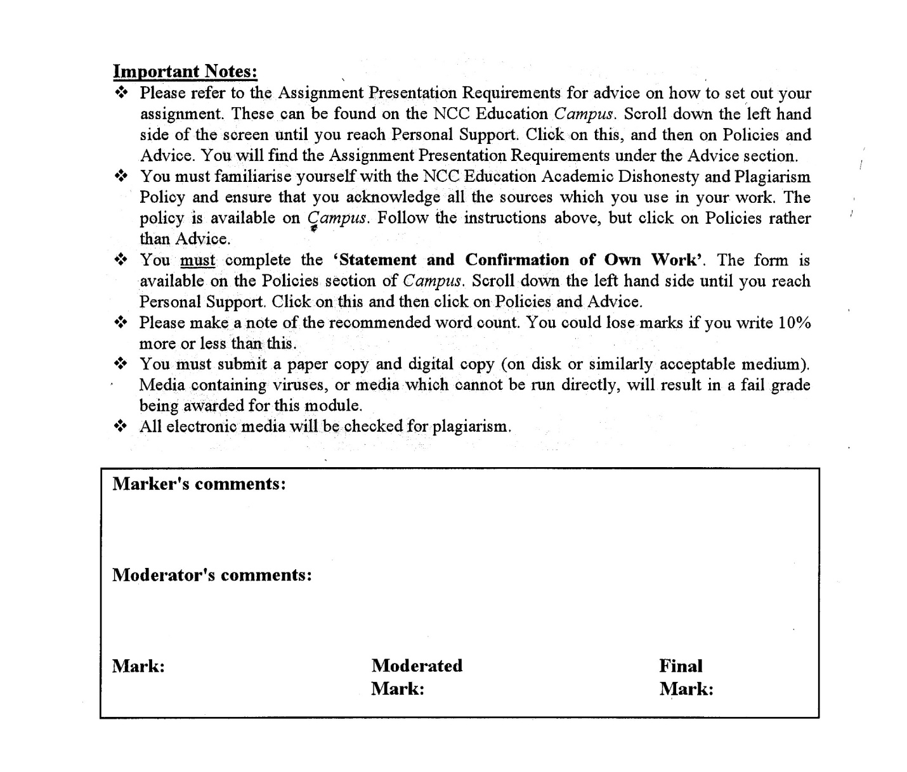



**Statement and Confirmation of Own Work**

**Programme/Qualification name: L4DC**

***All NCC Education assessed assignments submitted by students must have this statement as the cover page or it will not be accepted for marking. Please ensure that this statement is either firmly attached to the cover of the assignment or electronically inserted into the front of the assignment.***

**Student declaration**

**I have read and understood NCC Education’s Policy on Academic Dishonesty and Plagiarism.**

**I can confirm the following details.**

**Student ID/Registration number :**

**Name : Thi Han Naing**

**Centre Name : KMD COMPUTER CENTRE (YANGON)**

**Module Name : COMPUTER SYSTEMS**

**Module Leader : HEIN SITHU NYUNT**

**Number of words : ( ) words**

**I confirm that this is my own work and that I have not plagiarised any part of it. I have also noted the assessment criteria and pass mark for assignments.**

**Due Date :**

**Student Signature :**

**Submission Date :**

**Table of Content**

**TASK 1**

**WINDOWS INSTALLATION**

Introduction

The assignment includes window installation, Linux installation and faulty PCs. Window installation includes installations of Windows, antivirus software, office software and some free utility. In Linux installation, ubuntu Linux installation, setting up administrator and standard user, network setting up, how to install application on Linux and test plan in Linux are include. For faulty PCs, some parts of the unit system errors’ solutions are included.

1. Installation of windows
2. Stages of window installations.

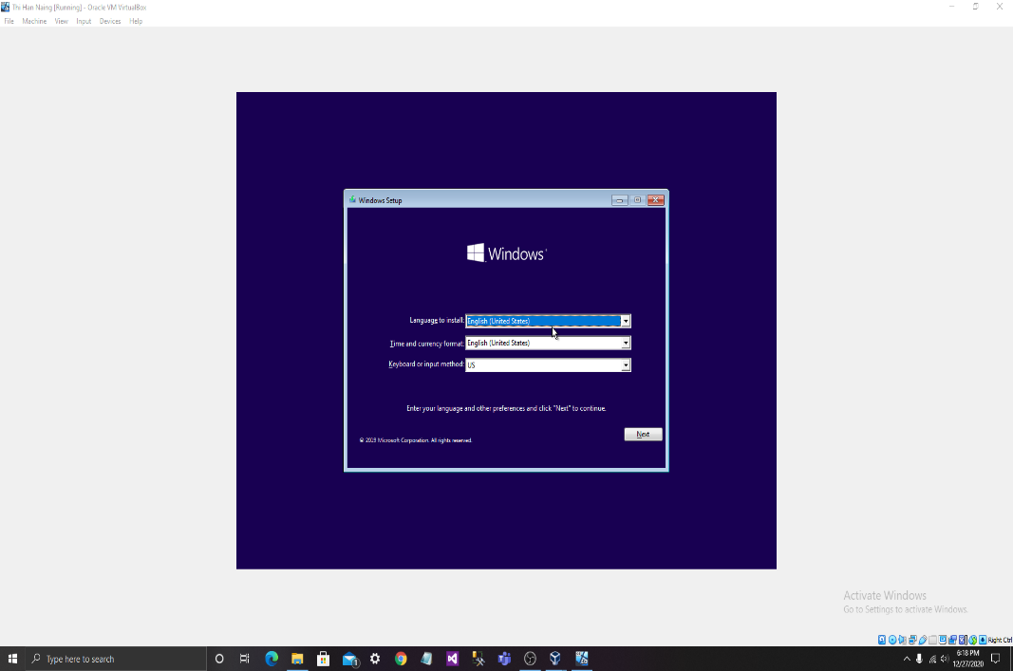

Fig1: Choose US language to install.

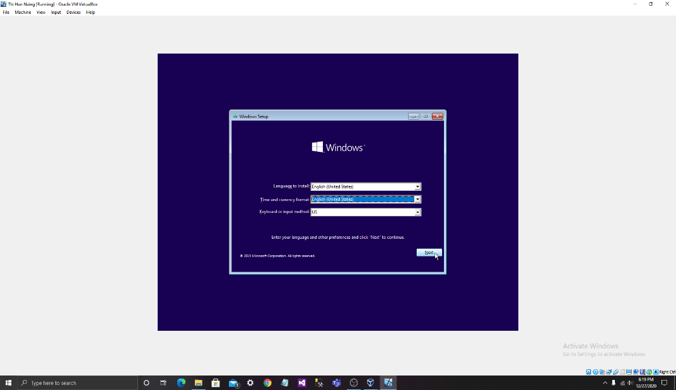

Fig2: Choose English.

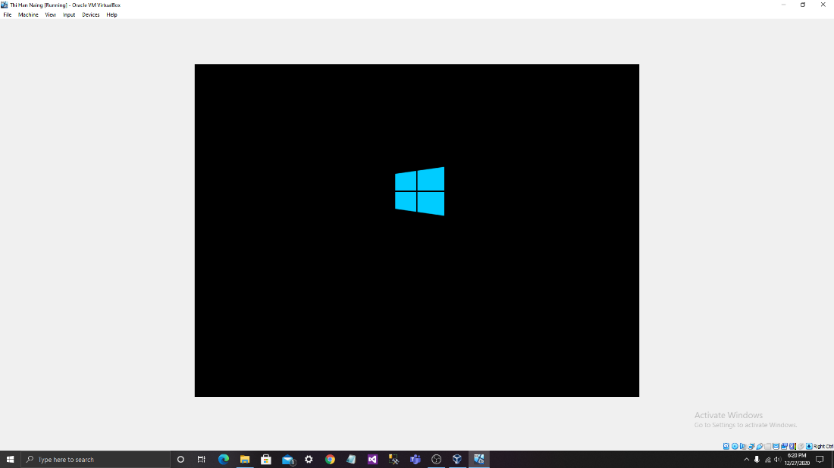

Fig3: Wait for a while.

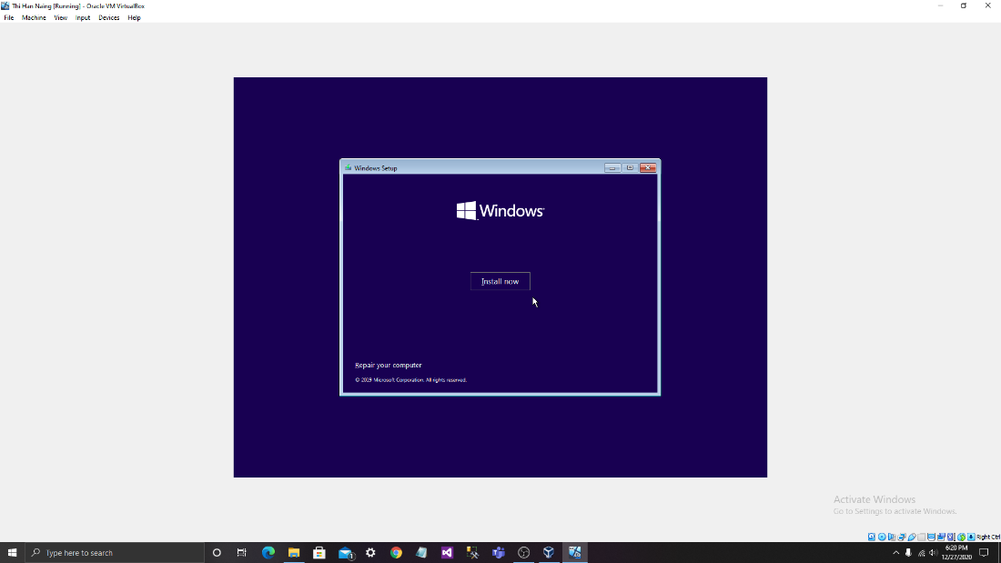

Fig4: Click install now to start installation.

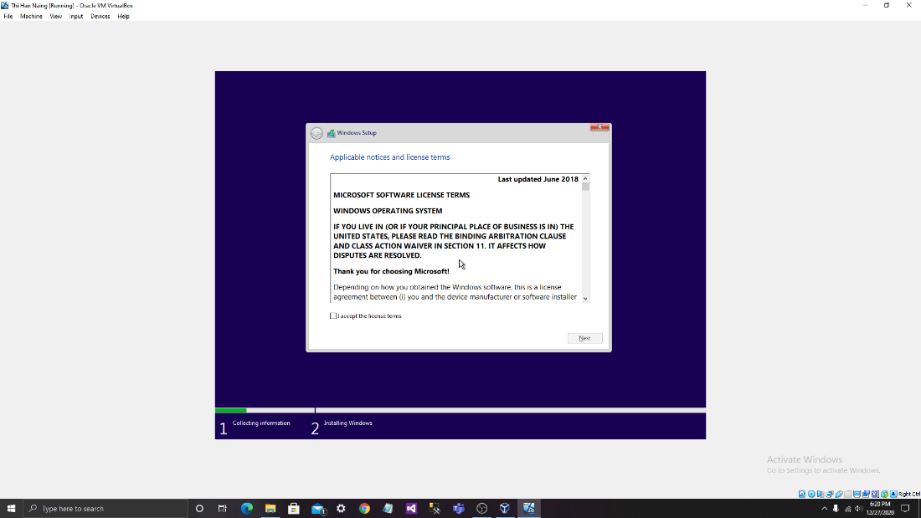

Fig5: Agree the license terms.

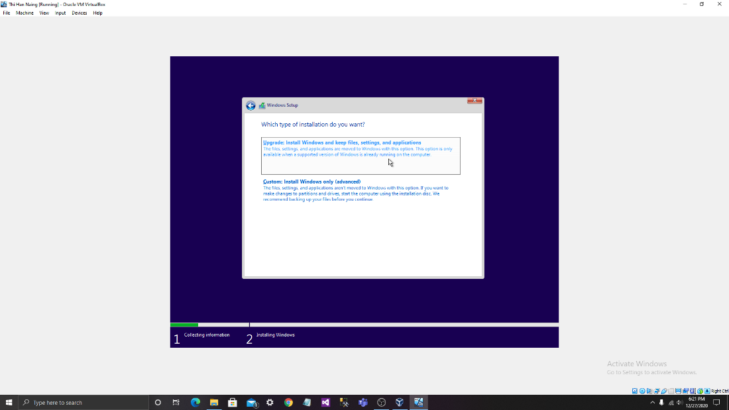

Fig6: If you already have window, click upgrade. If not install all.

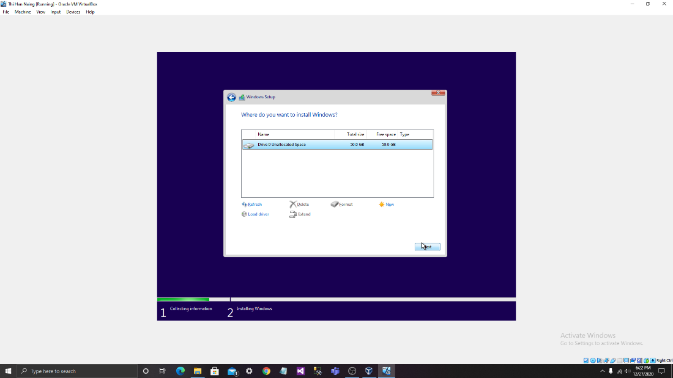

Fig7: Choose file on HDD or SSD and click next.

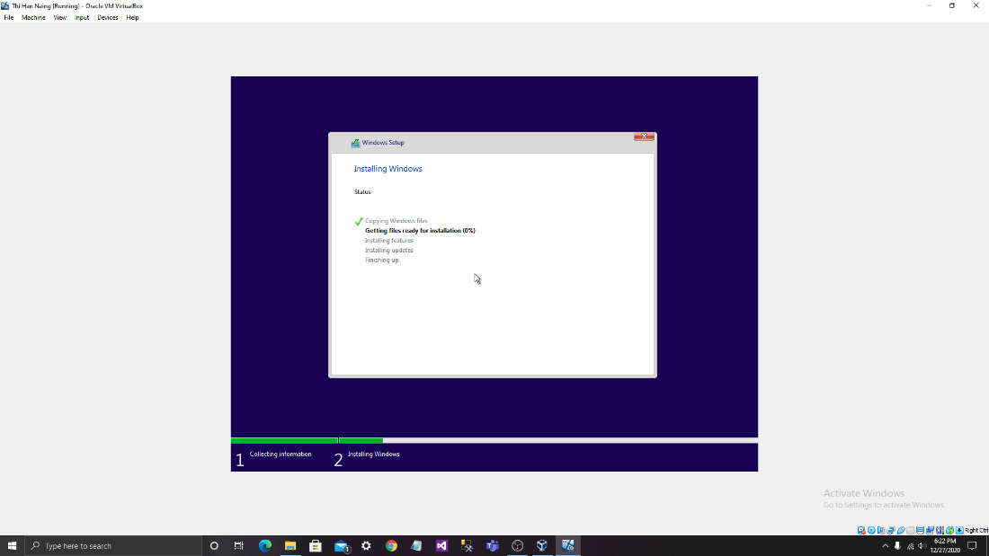

Fig8: Wait for a while. Step 2 will take a long time.

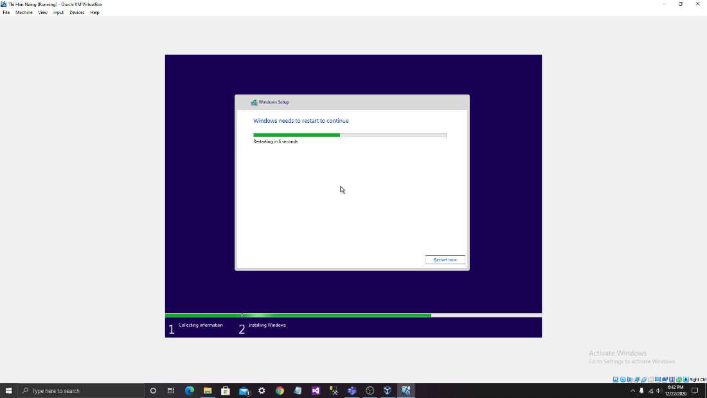

Fig9: Wait again.

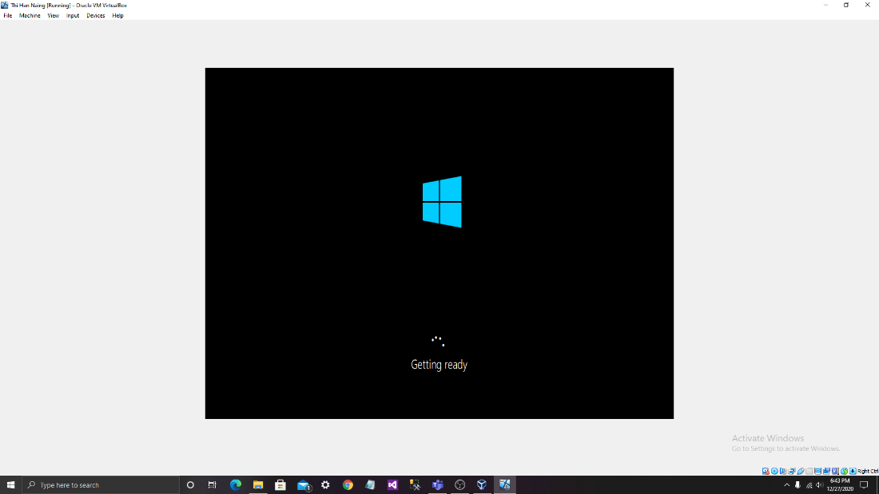

Fig10: It is getting ready.

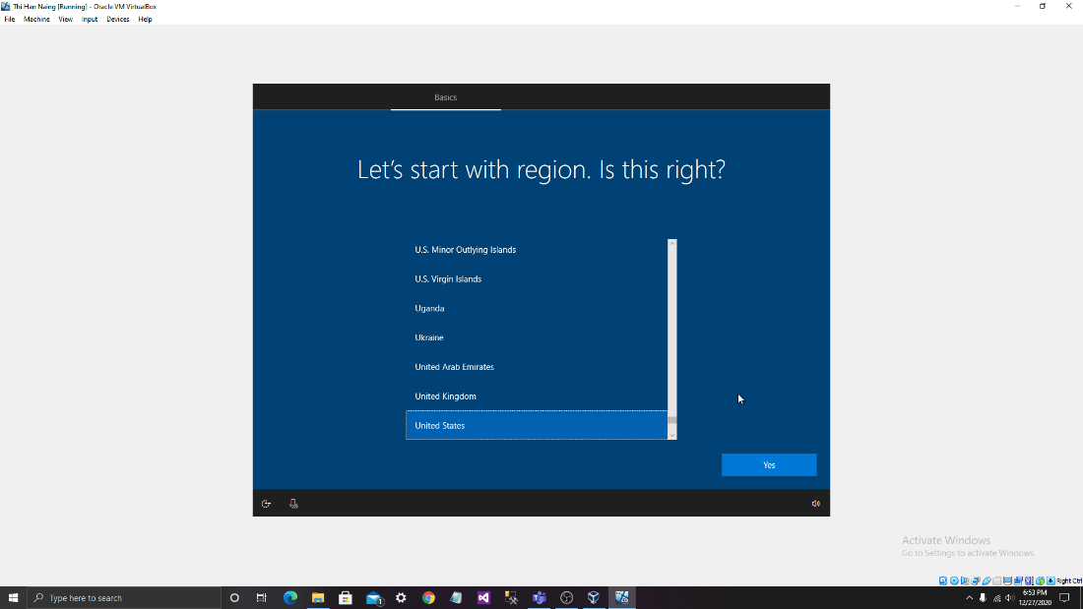

Fig11: Choose the regin.

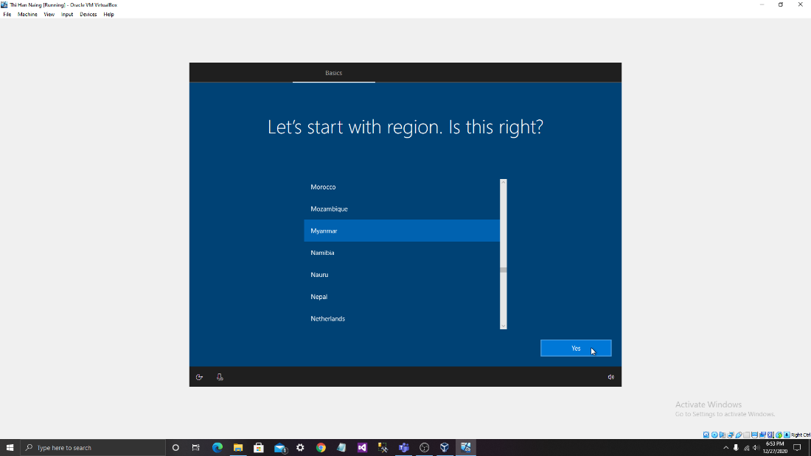

Fig12: Chose Myanmar.

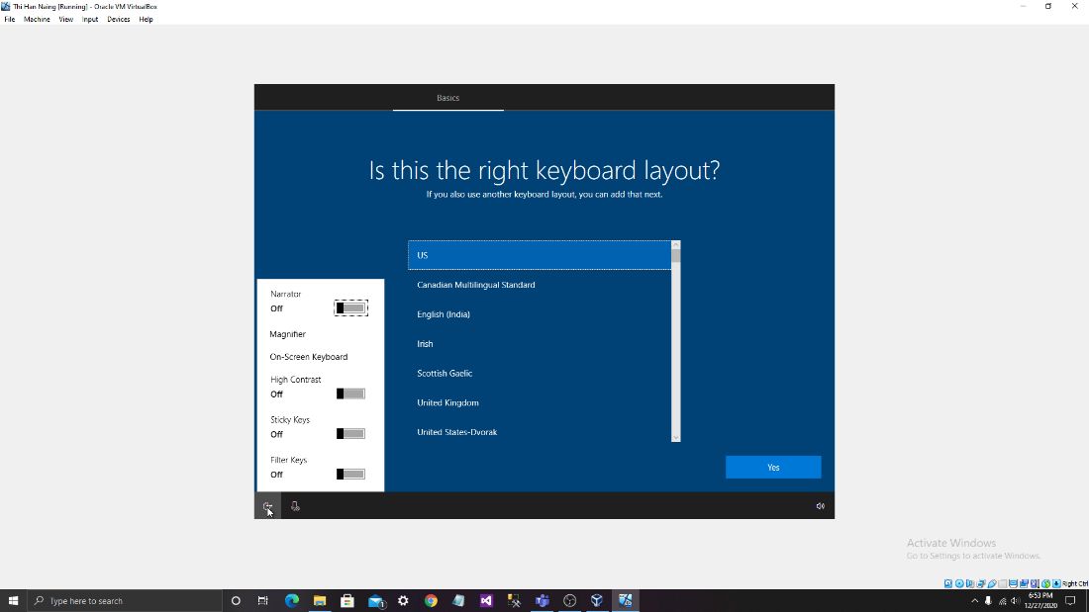

Fig13: Choose for the keyboard.

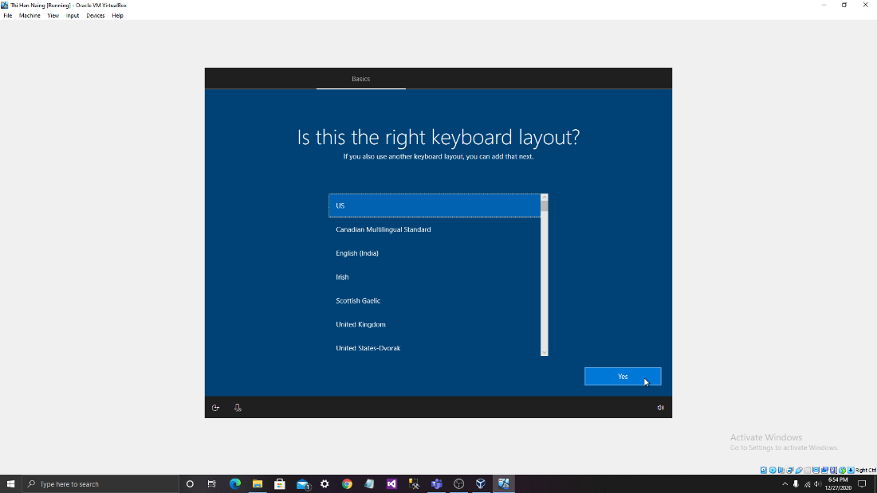

Fig14: Chose US. That is familiar to all.

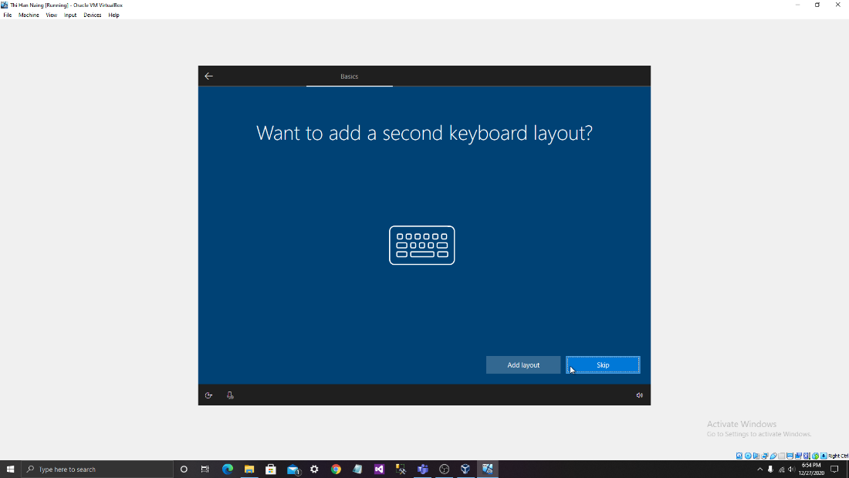

Fig15: This isn’t necessary. So, it must need to be skipped.

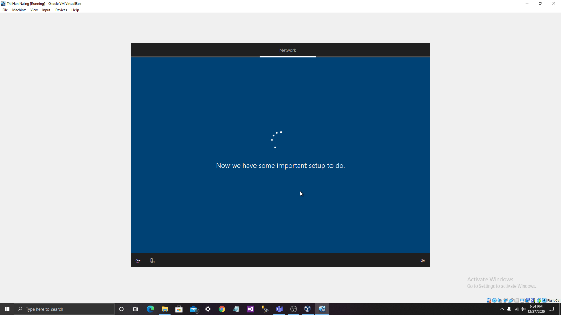

**Fig16: Wait for a moment.**

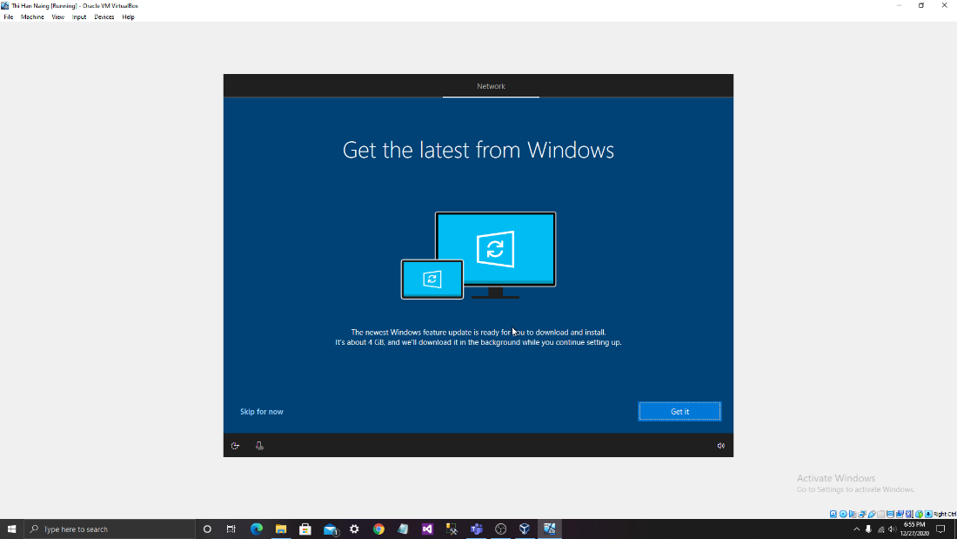

Fig17: Click “Get it” or “Skip for now”.

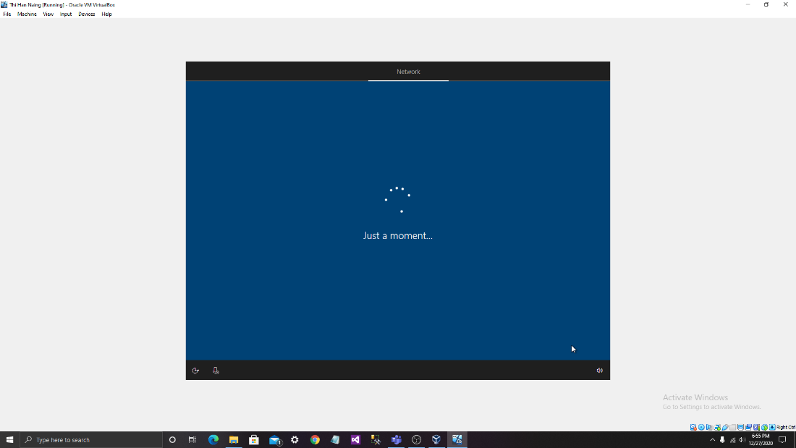

Fig18: Wait again.

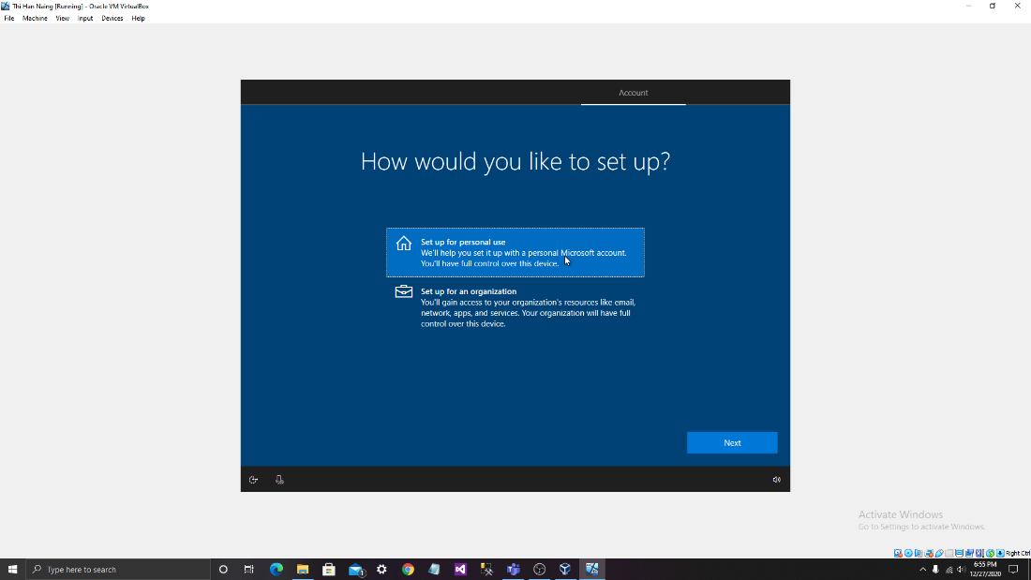

Fig19: Choose one from those.

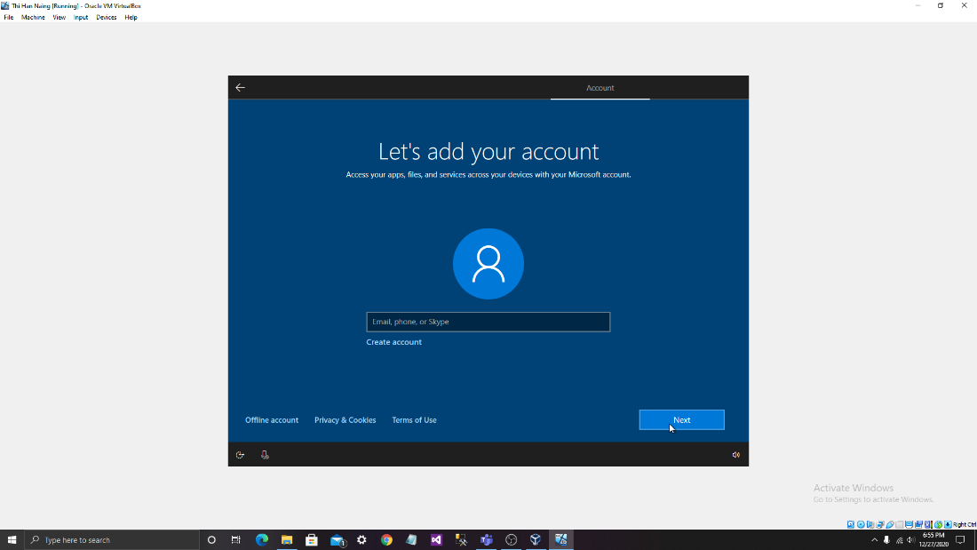

Fig20: If already have an account, can be added. If not create.

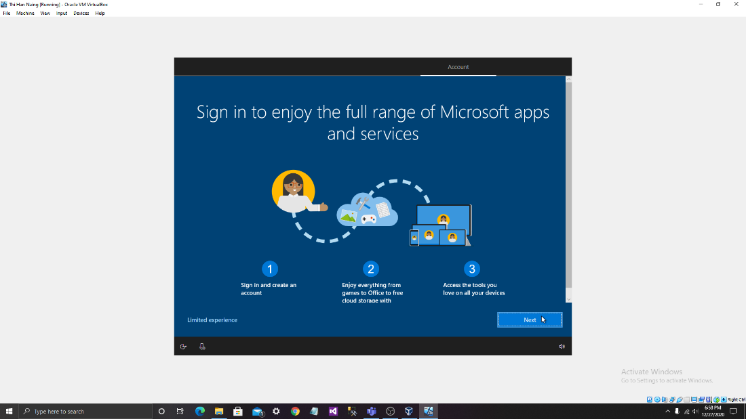

Fig21: This is kind of ads so just click next.

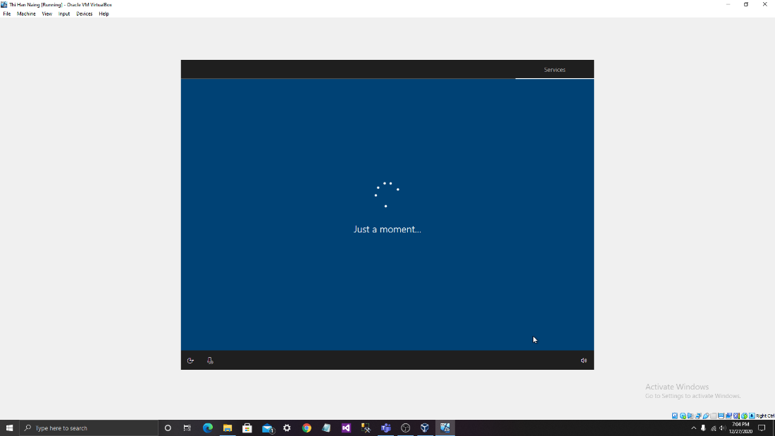

Fig22: Wait for a moment again.

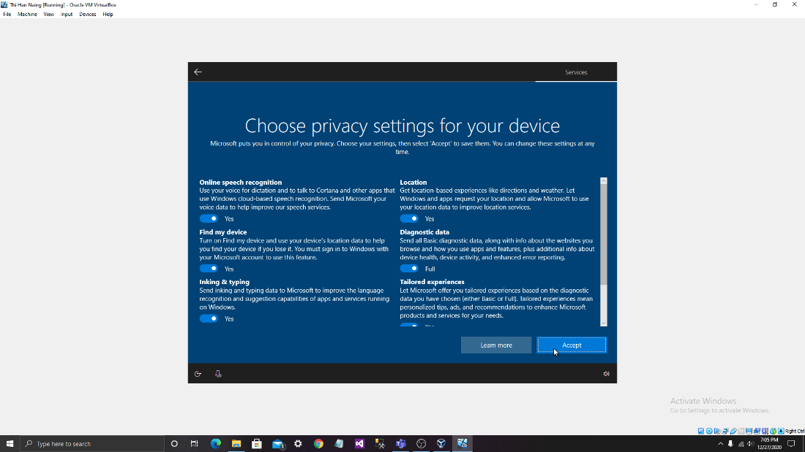

Fig23: Click ”Accept” after choosing the privacy setting.

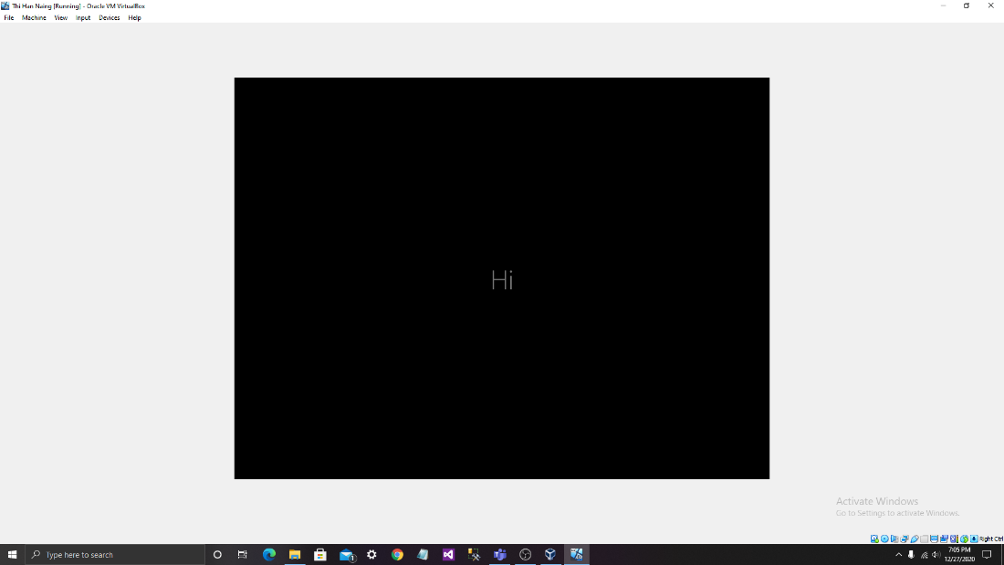

Fig24: Wait and the black screen will show.

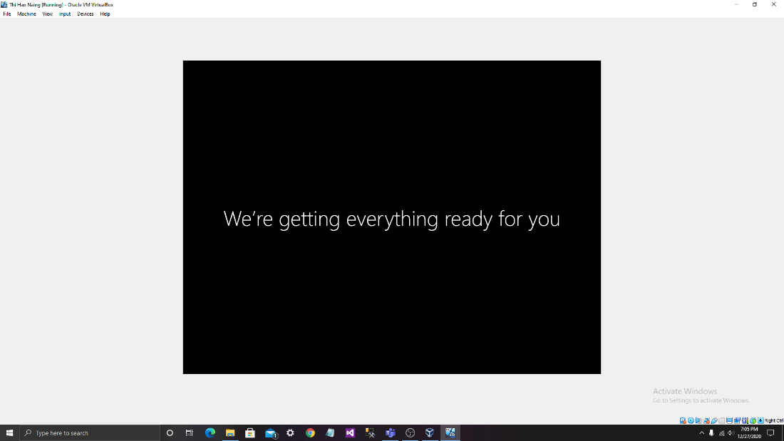

Fig25: The screen is showing other things like this.

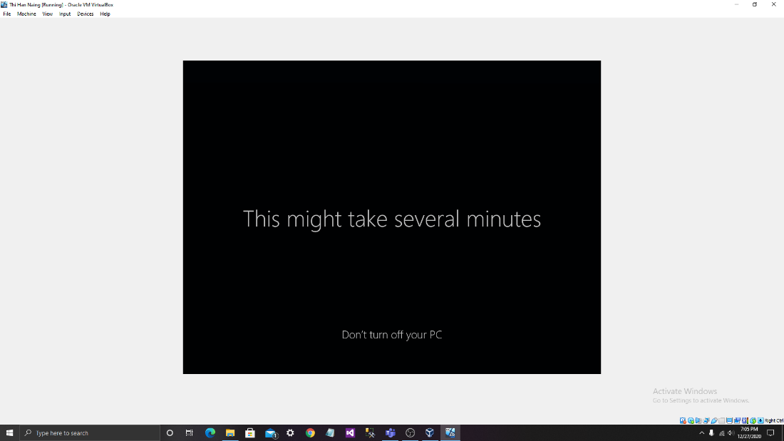

Fig26: And this.

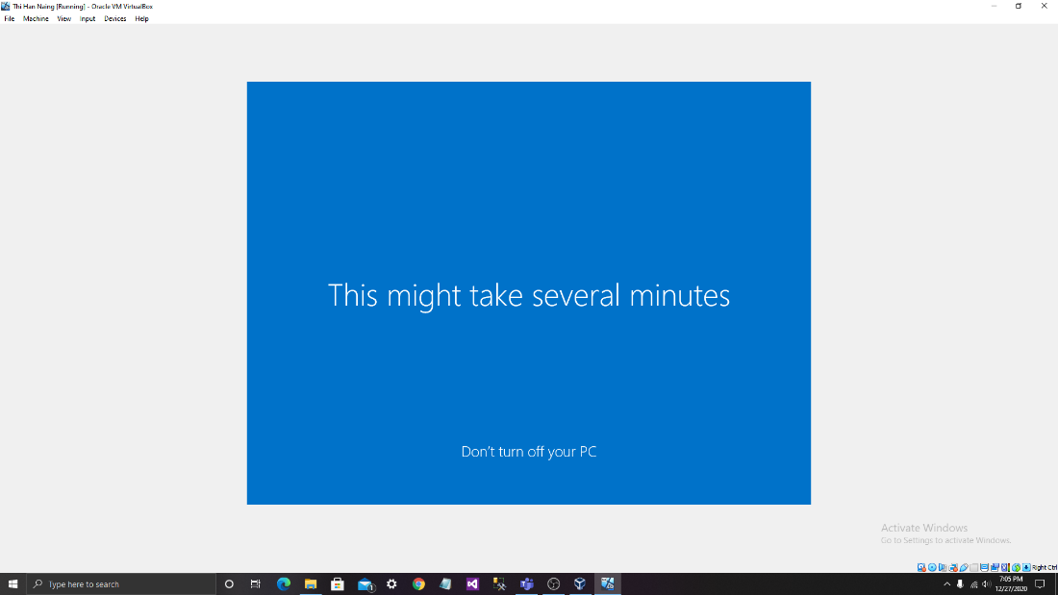

Fig27: Show in blue screen background.

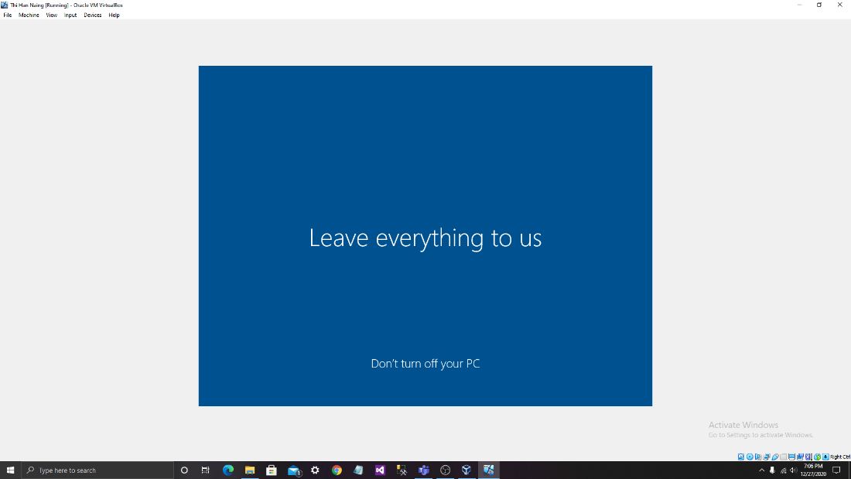

Fig28: Wait and don’t close the computer during the process. The stages of installation is finished now.

b. Update driver and the their source locations.

The drivers make the connections between software and hardware. They are part of OS so every OS has drivers. For the window the method for searching and updating driver is shown below.

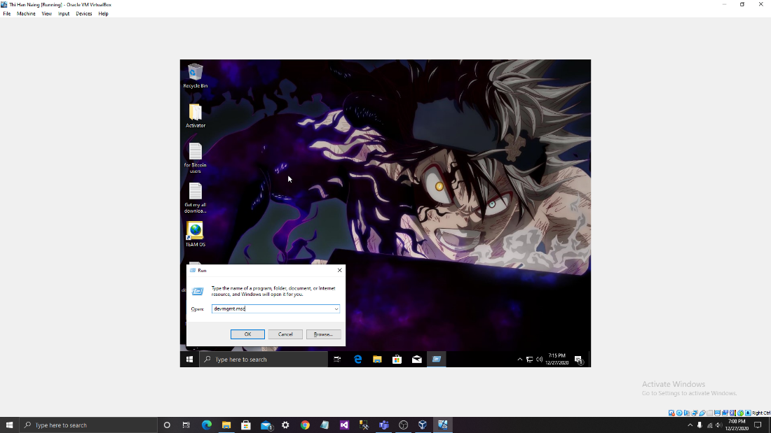

Fig29: Call Run by pressing “window key” and “R” and click “devmgmt.msc” for device manager.

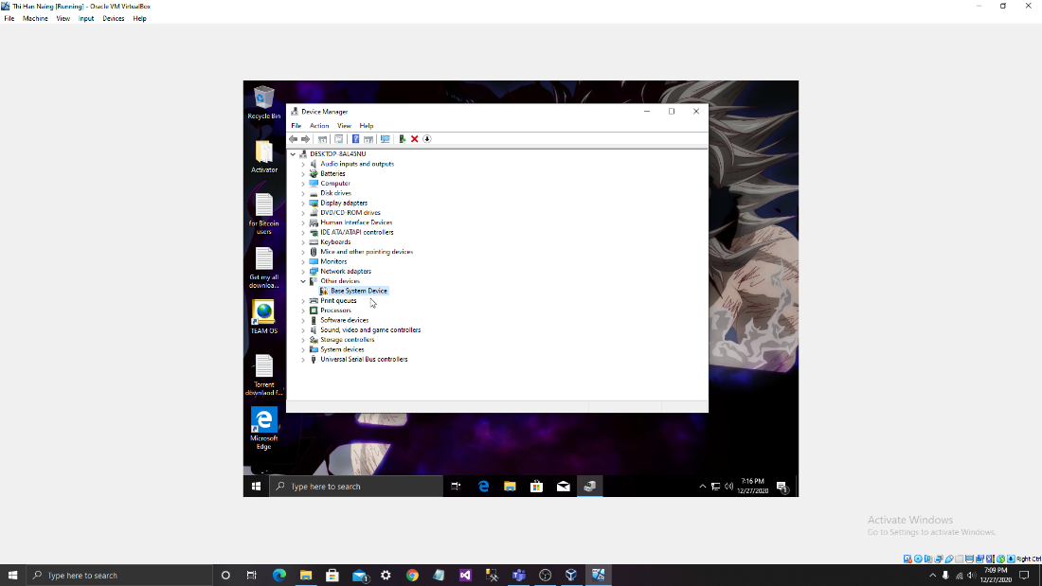

Fig30: Search for an error.

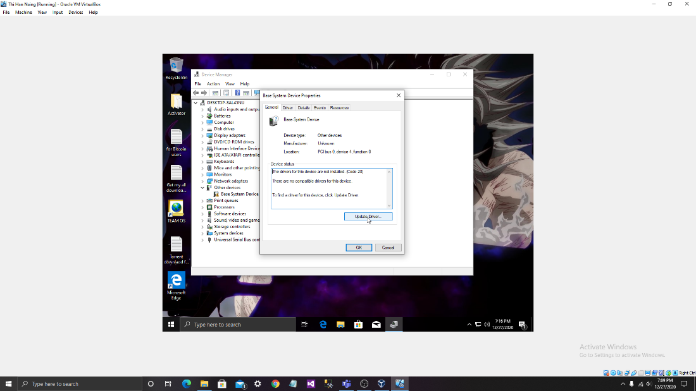

Fig31: Update the driver.

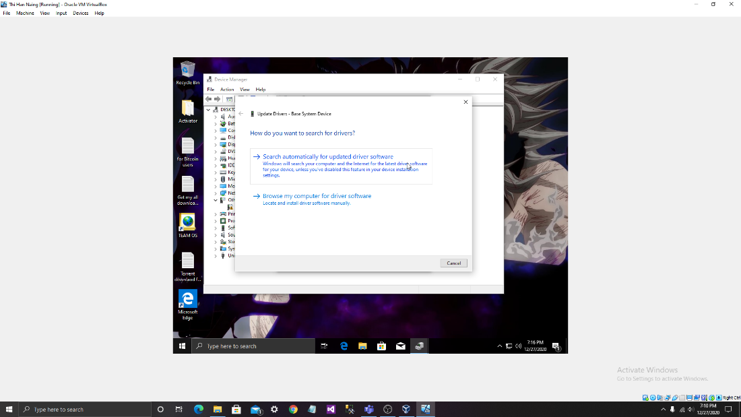

Fig32: Click the upper one.

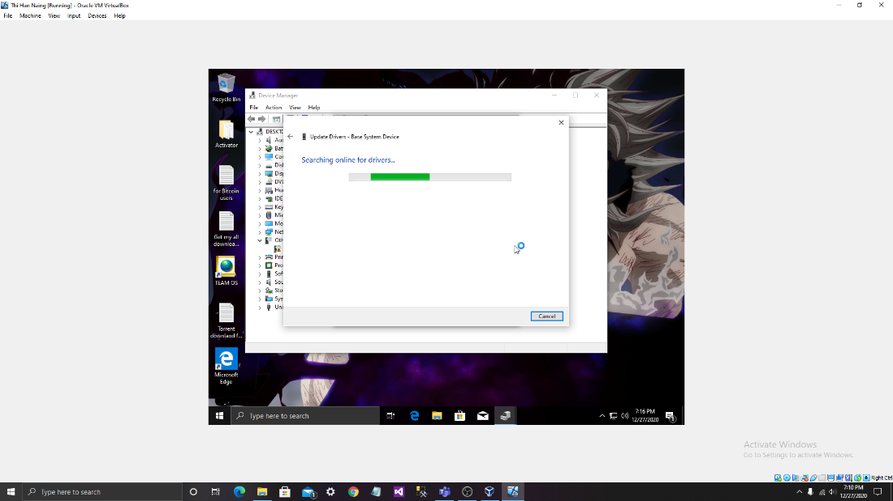

FIg33: Wait for a little second.

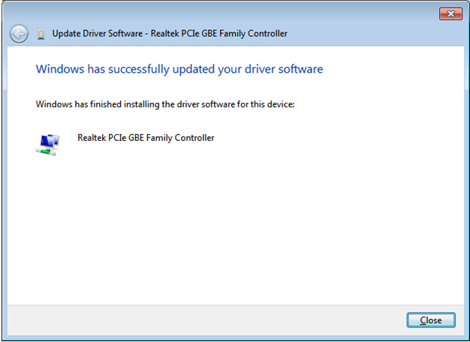

Fig34: The window is now successfully updated.

c. Unresolved issues.



Fig35: the device drivers are sometimes show errors during installation. To solved this, this must need to be updated and the state is shown above.

2. Installation of antivirus software

a. The antivirus software from below is "Kaspersky Anti-Virus". This version is 20.0. 14.1085 and it was released on July 24, 2019.

This antivirus software is developed by Kaspersky company. It can be used

free for a month and can also use with product key.

b.

Step 1:

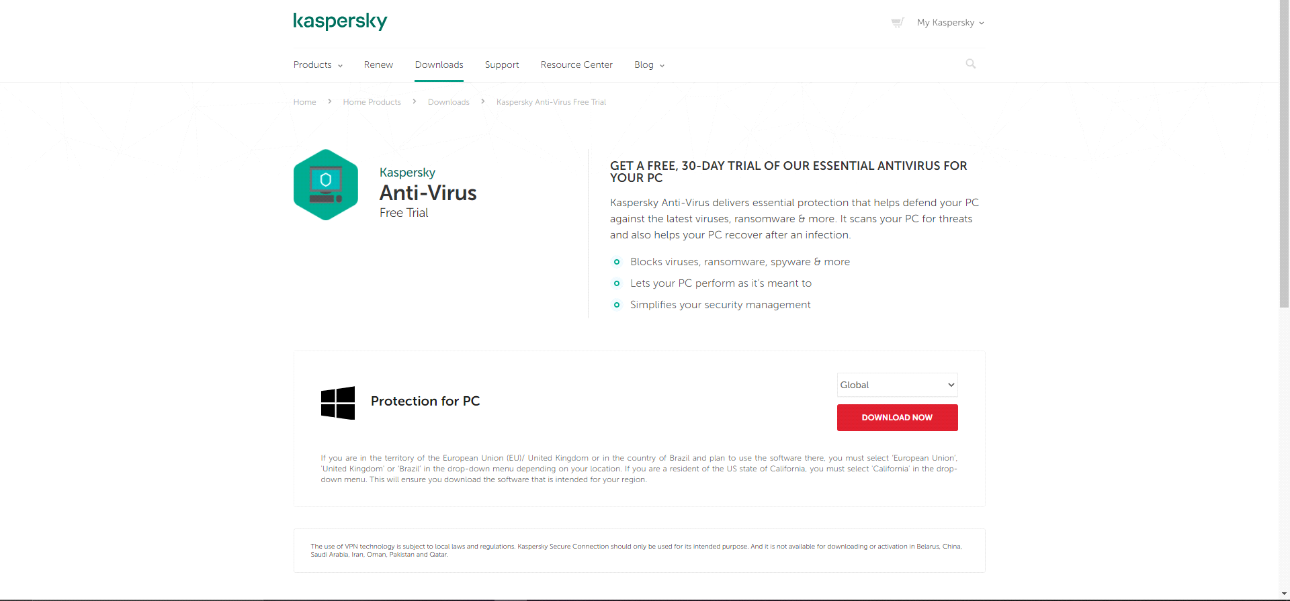

We can search it on the Kaspersky website and download it for free.

Step 2:

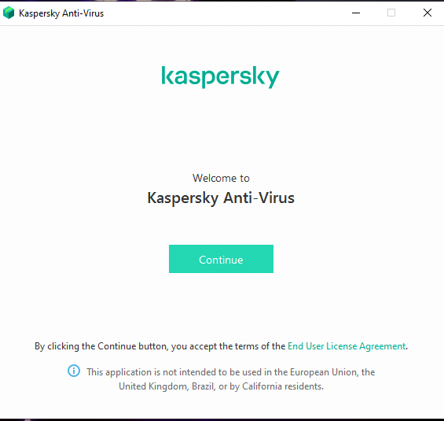

After downloading the app this screen will come next and then click "Continue" for the next step.

Step3:

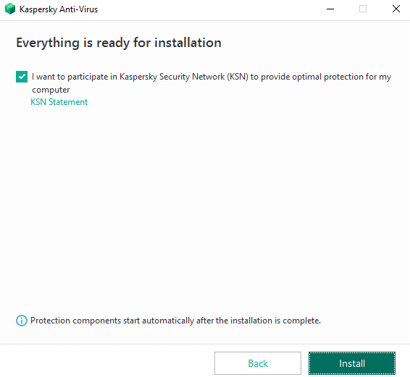

Click the install button to install the "Kaspersky Anti-Virus" .

Step 4:

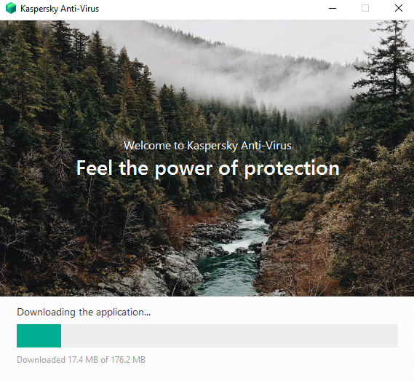

Keep a little while for downloading the application

Step 5:

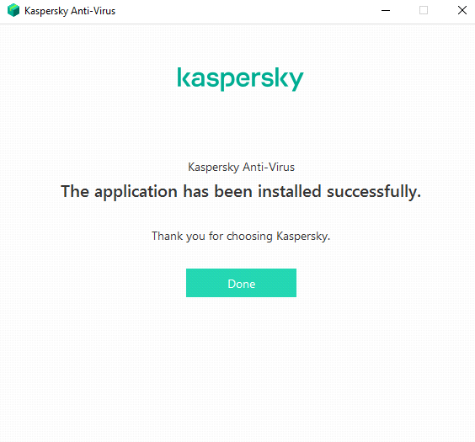

Now the application has been installed. We can enter the app by clicking the "Done" button.

Step6:

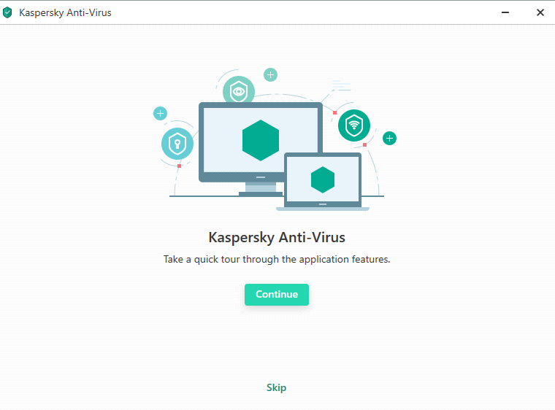

For choosing the features, we need to click "Continue" button. If not, we can skip it.

C. When we downloading or installing, some errors can be seen like below.

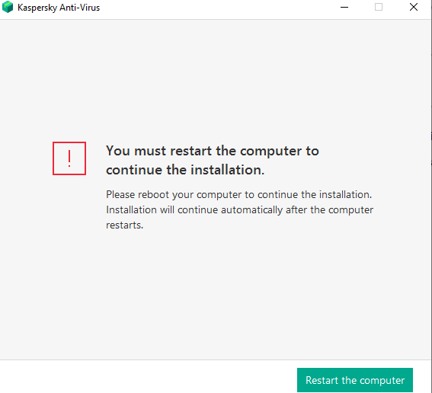

For this it is better restart our computer

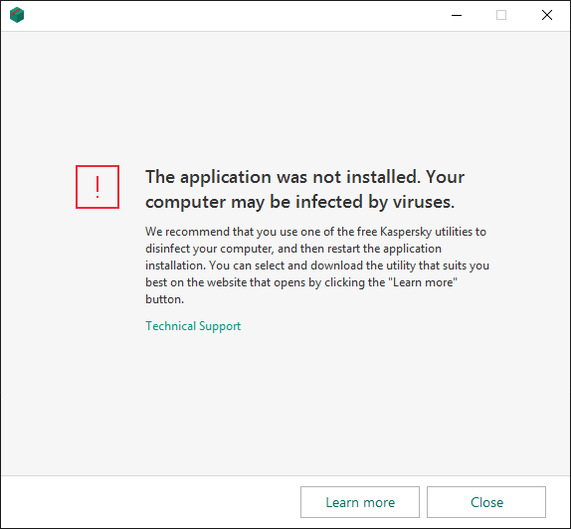

If application was not installed, we need to close this and re-install again

D. For updating

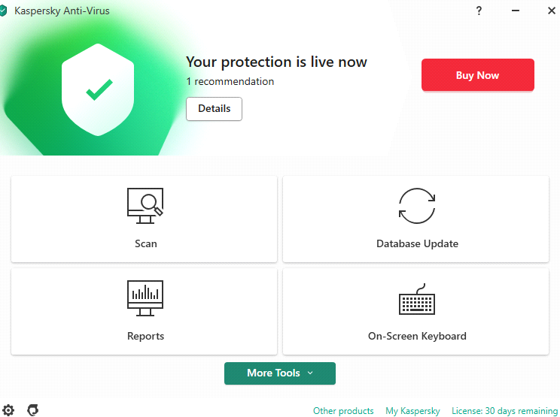

Click the "Database Update" box.

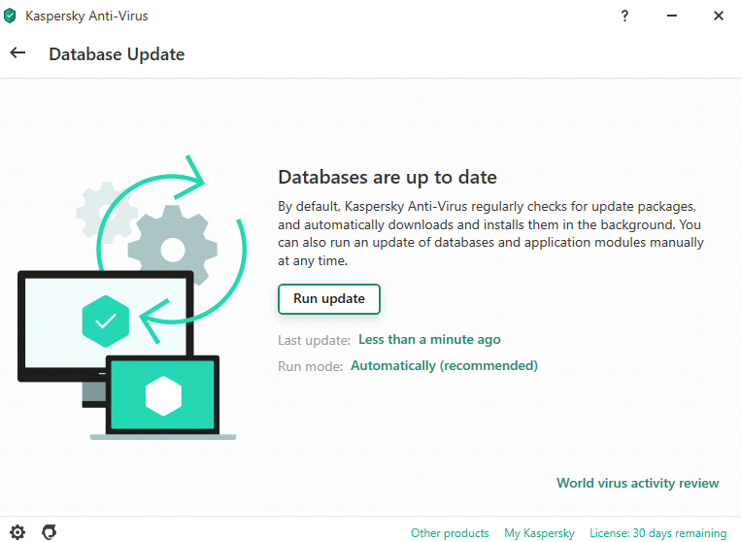

And then click "Run Update" to get successfully updated.

3.Installation of office software

1. Office softwares are essential in nowadays for everyone. With the help of these software our jobs become easier. There are so many office software and among them, this is "FreeOffice" aka "SoftMakerOffice" which is free to use and developed by "SoftMaker" company. This office is free to use as its name.

1. To install FreeOffice software, there are steps shown below.



1.First go to their website.

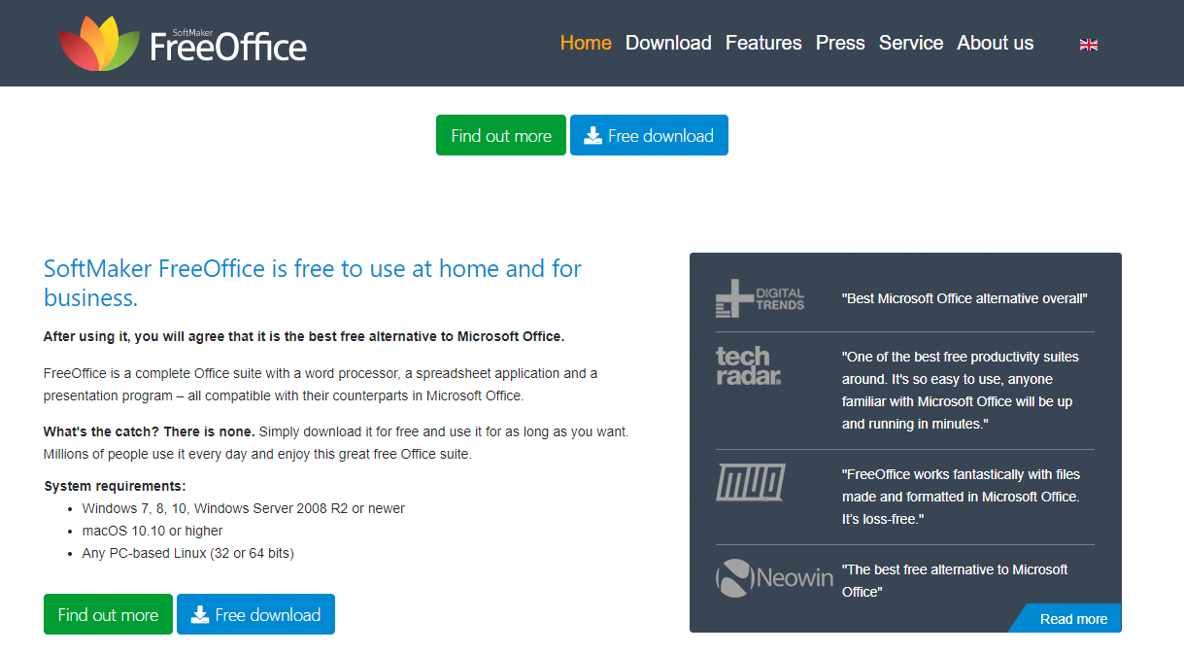

2.And then click on "Free download" to download the software.

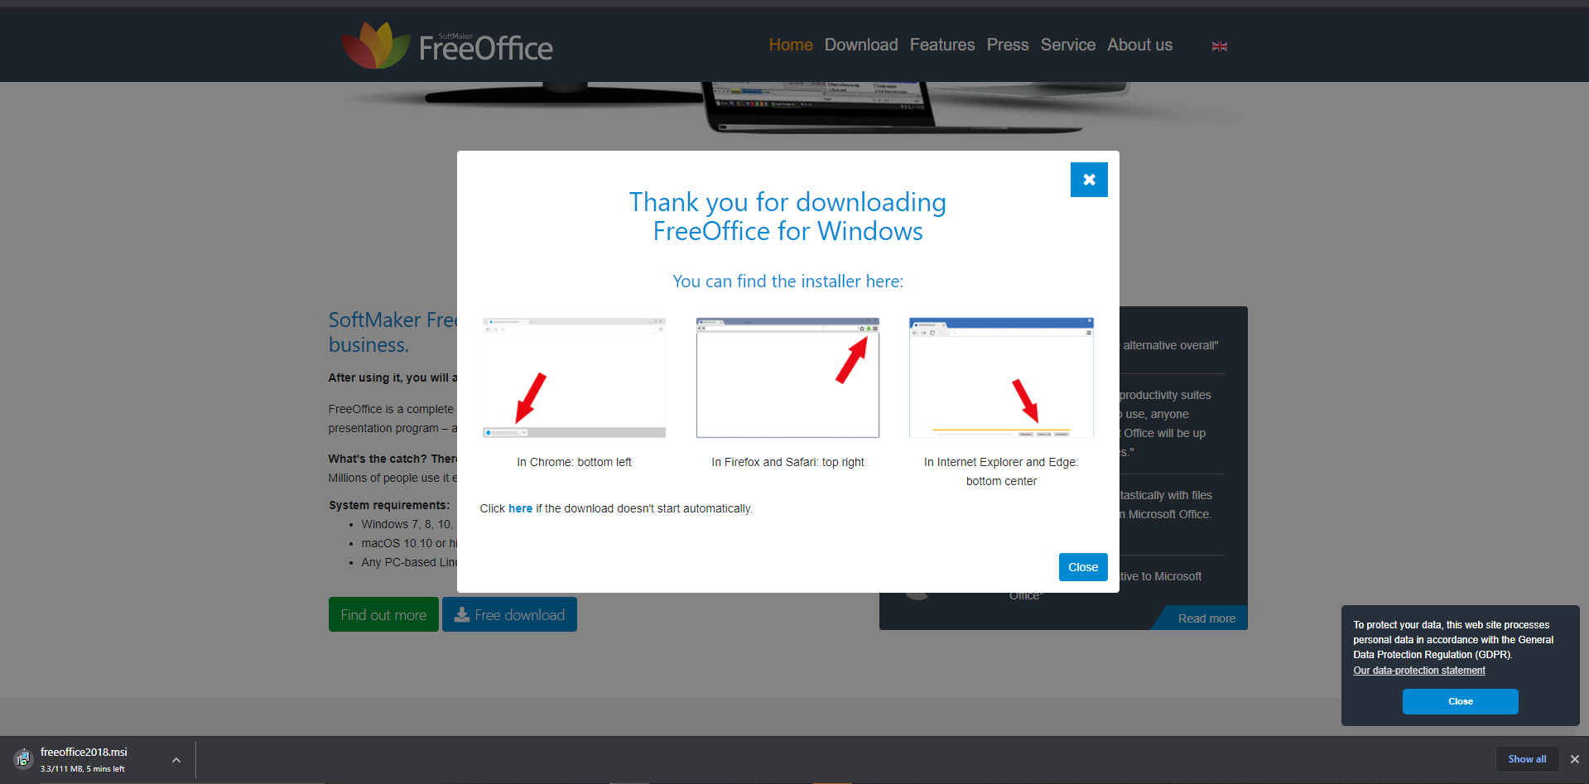

3.And wait for it to finish downloading.

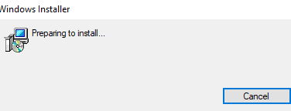

4.After downloading, please wait for an installation.

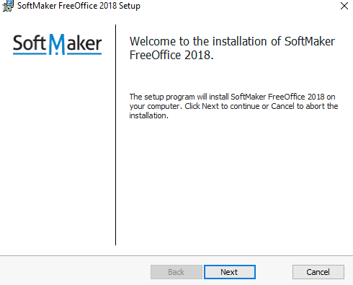

5.Now click the "Next" to reach the next page.

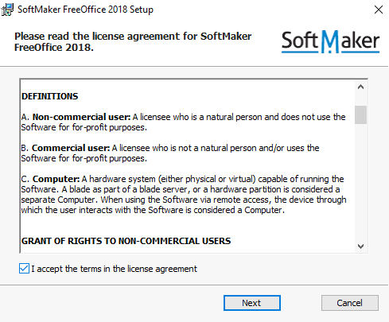

6.Accept the license agreement and click the " Next " again.

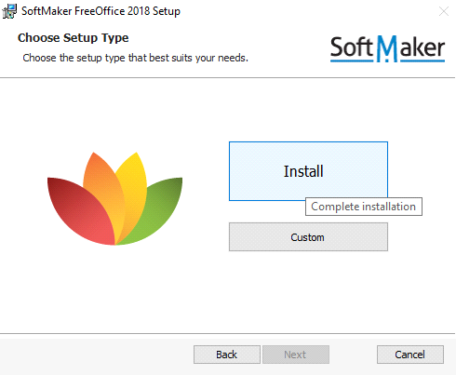

7.And now click the big "Install" button to complete the installation.

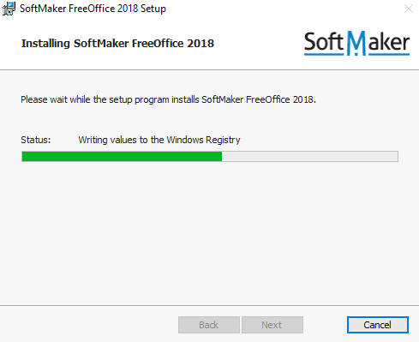

8.Please wait again to setup the program.

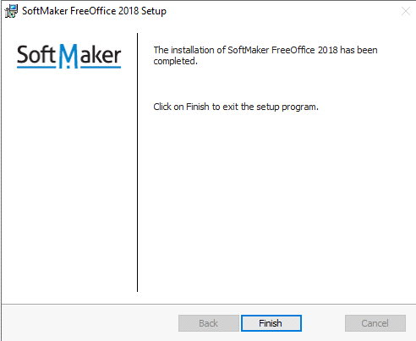

9.Now click "Finish" to finish the setup program.

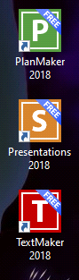

10.Now we got three software from Softmaker FreeOffice.

1. After installing the softmaker, we can see some kind of errors from its office.

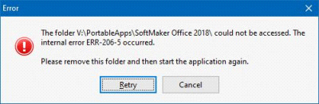

If this kind of error happen, just uninstall the applications and delete the file in the folder and try to install the application again.

4.Installation of free utility

1. Utility software is a free software which helps to maintain and control computer resources and makes computer runs faster. Some utility programs examples are anti-virus and backup softwares."CCleaner" is one of these free utility softwares and useful one. I choose it because "CCleaner" is really easy to install and use. And its functions are simple to use.
2. Installation stages of CCleaner

Step 1:

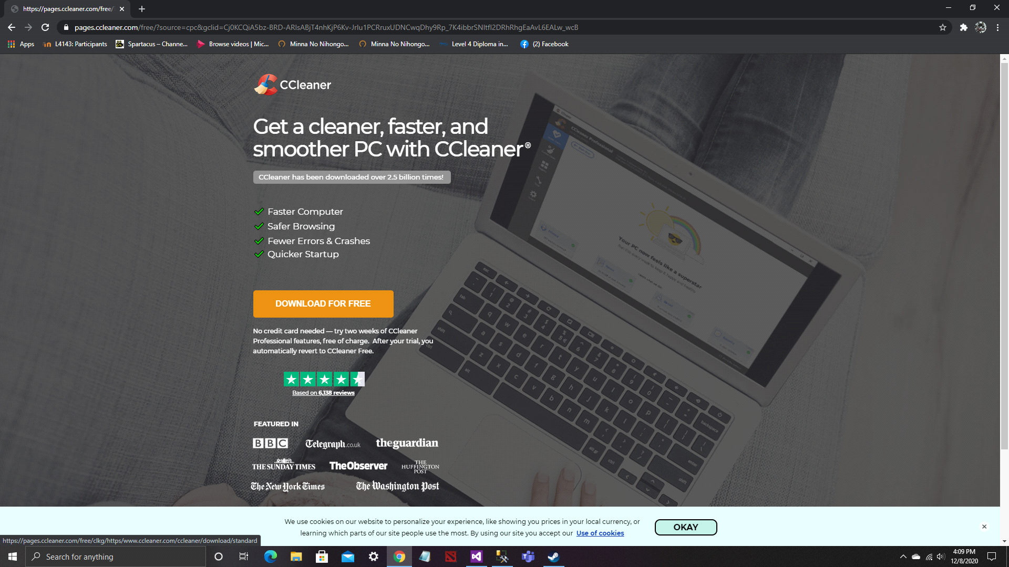

-We can download it on their website freely.

Step 2:

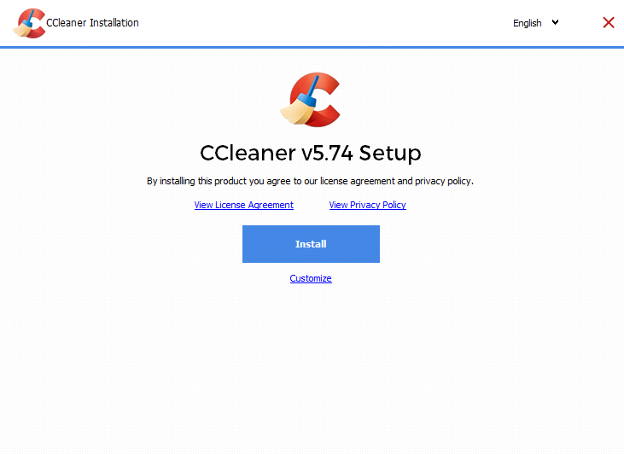

-Now we can install the software after downloading.

Step 3:



-If this open, we can choose either decline or accept.

Step 4:

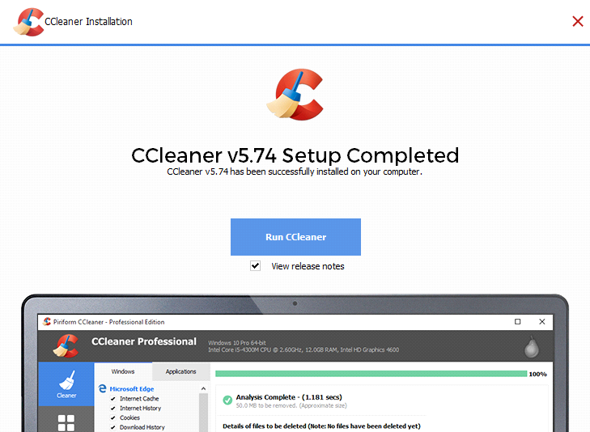

-After installing is finished, we can run CCleaner now.

1. Problems and unresolved issues.

We can only clean the current user account .If we want to clean, we need to log in to other account.

-Some lower verions are not compatible with Window 10. For this problem Microsoft will notify to update and we can update to the lastedt version.

**TASK 2**

**LINUX INSTALLATION**

1. (a) Linux is an operation system like window and mac. But on Linux platform, there are many different types of OS for each purpose. Some examples of Linux are Kail, ubuntu, Debian and Gentoo, etc. The Linux below is the installation of ubuntu.

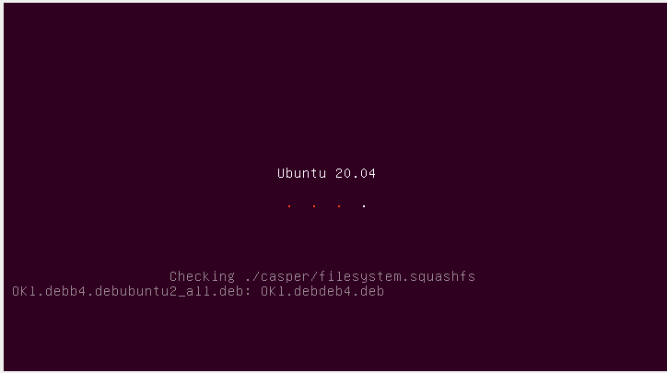

Fig 1: After choosing files for installations, the step can be started.

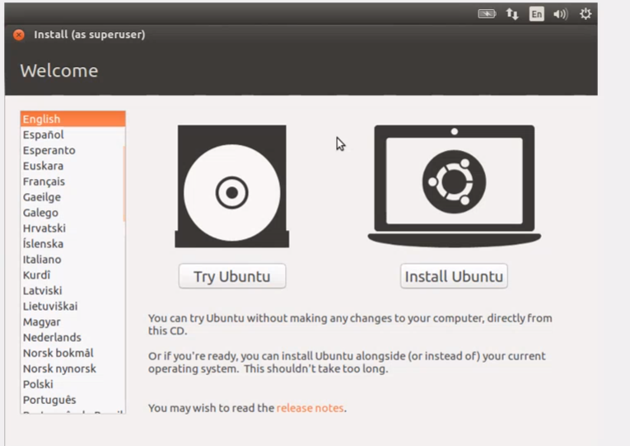

Fig2 : The purpose is to install Linux, so choose install ubuntu. Linux is not the same as the other OS systems in this way.

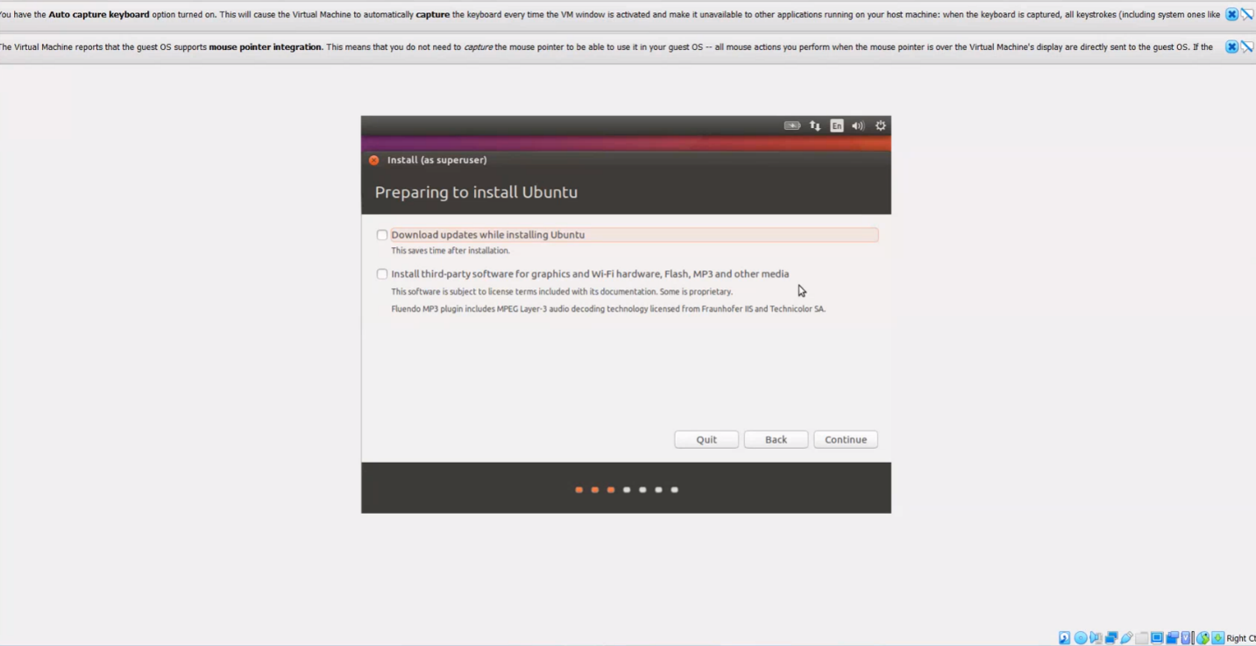

Fig3: If we want to update while installation, choose above. If not we can skip and download later.

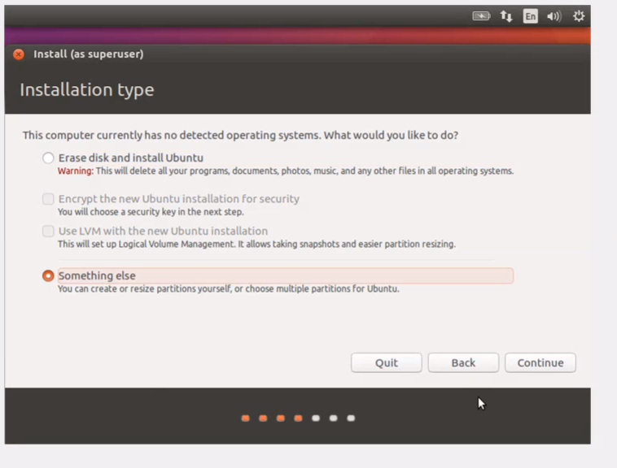

Fig4: Choose something else in order to do partitions by self.

(b) Disk partitions

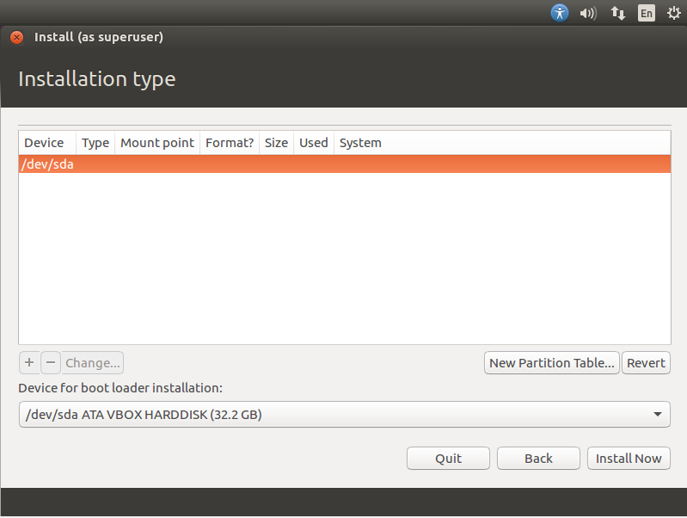

Fig 6: Choose new partition table.

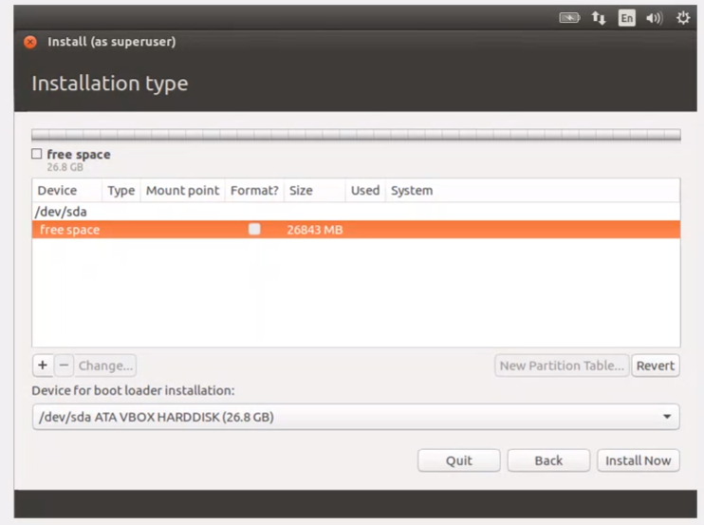

Fig7: Got new free space and make partitions now.

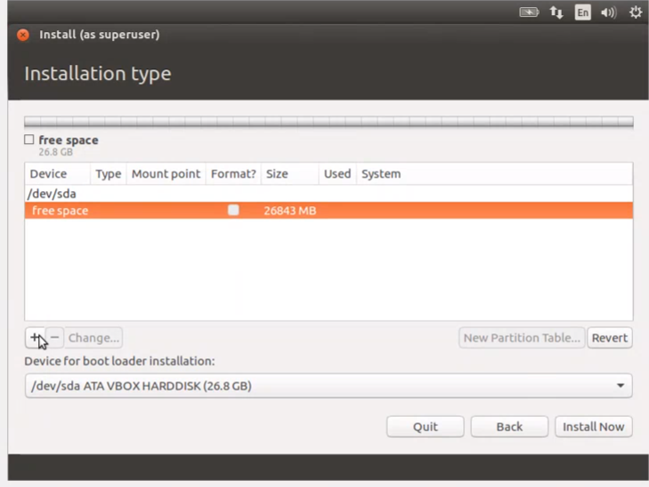

Fig8: To make partition click plus button .

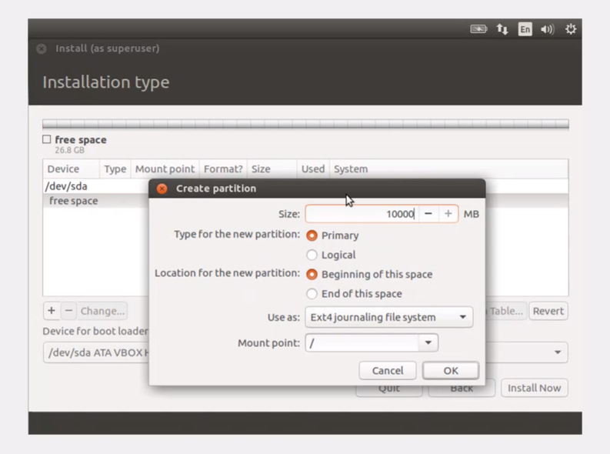

Fig9: For root partition choose as primary and choose “/” which means root in ubuntu Linux in mount point and for the size 1Gb is chosen.

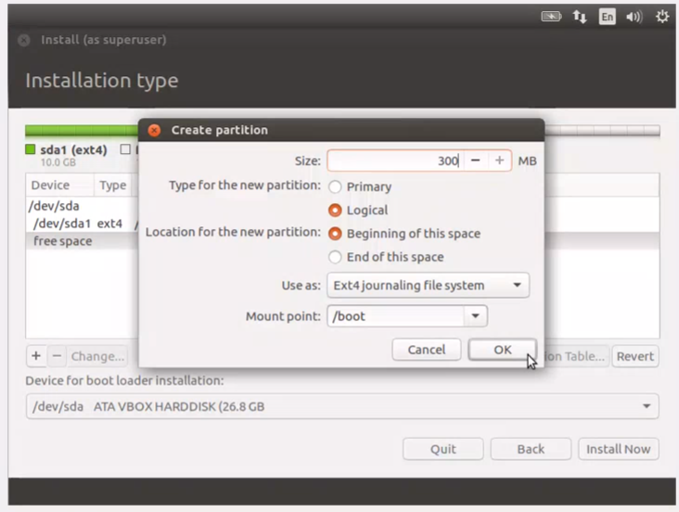

Fig10: For boot partition, chose 300MB and this time choose logical and search “/boot” in mount point.

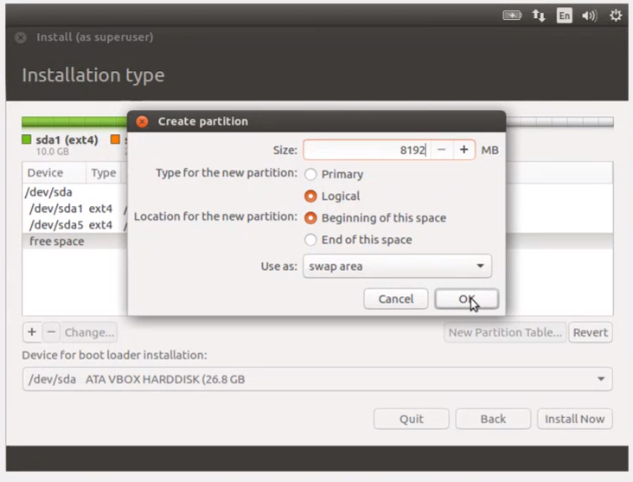

Fig11: For swap partition, size is 8192 which must be double than ram and this is logical also. And in this time in use as, choose swap area.

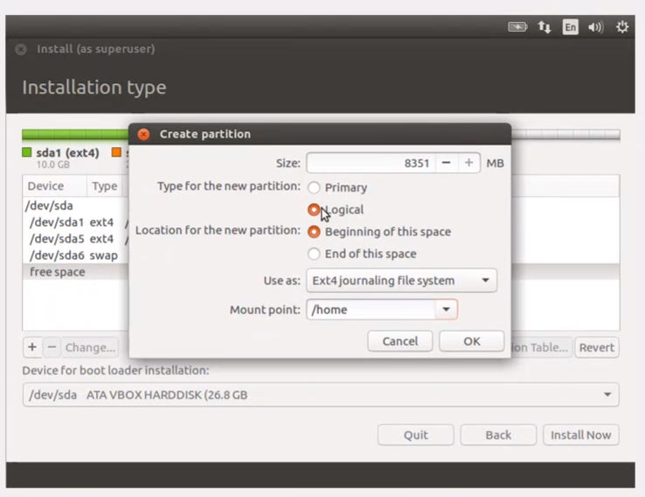

Fig12 : And let the other space for home partition.

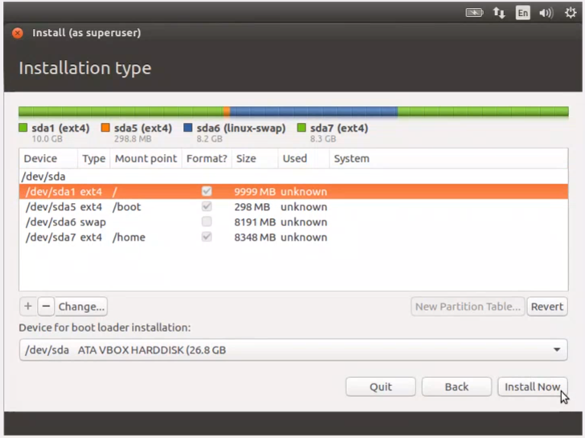

Fig13: select the root and click install now.

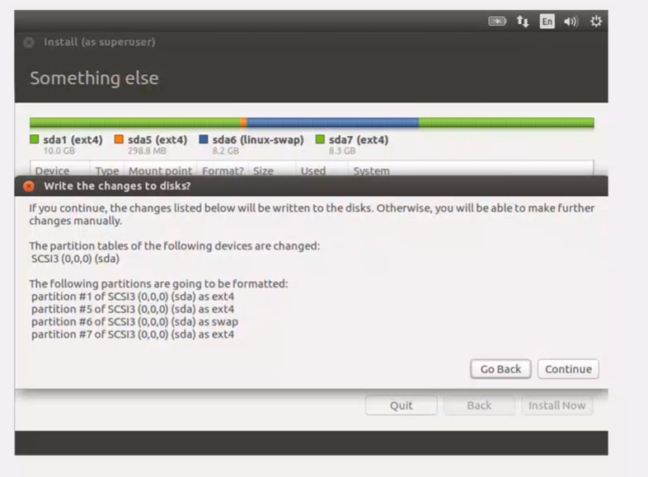

Fig14: Click continue.

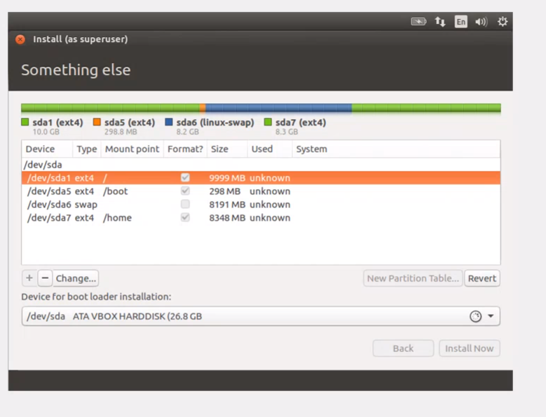

Fig15: And it is start to install now.

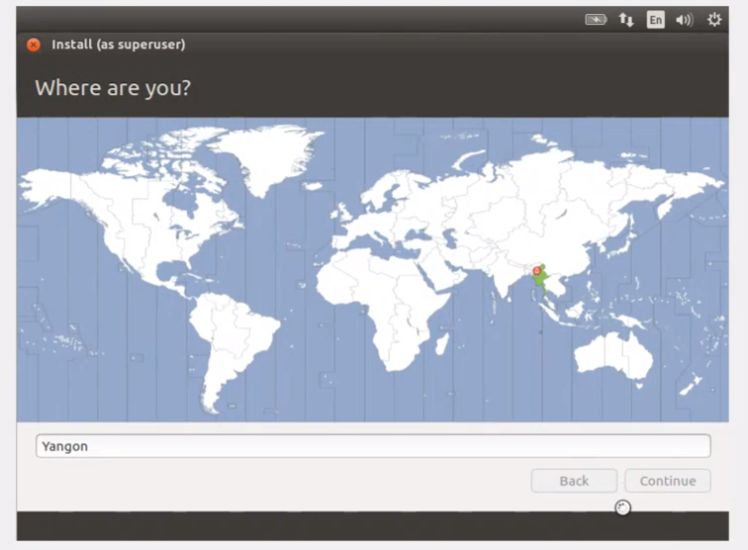

Fig16: Choose the region and click.

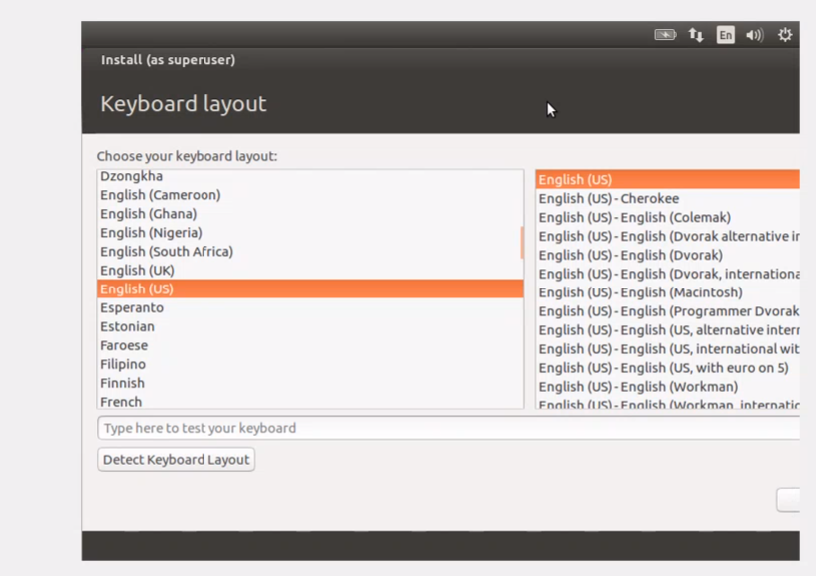

Fig17: Choose keyboard. Linux more specific in this place.

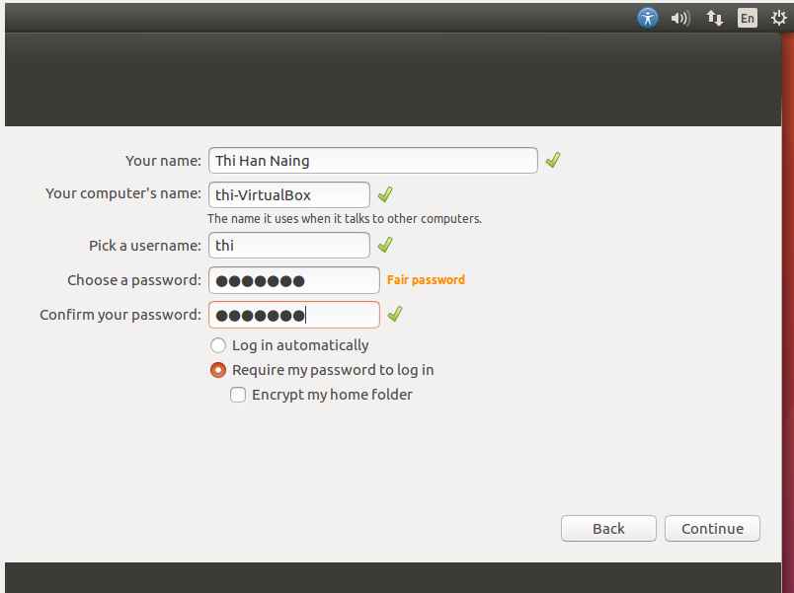

Fig18: Fill the informaion.

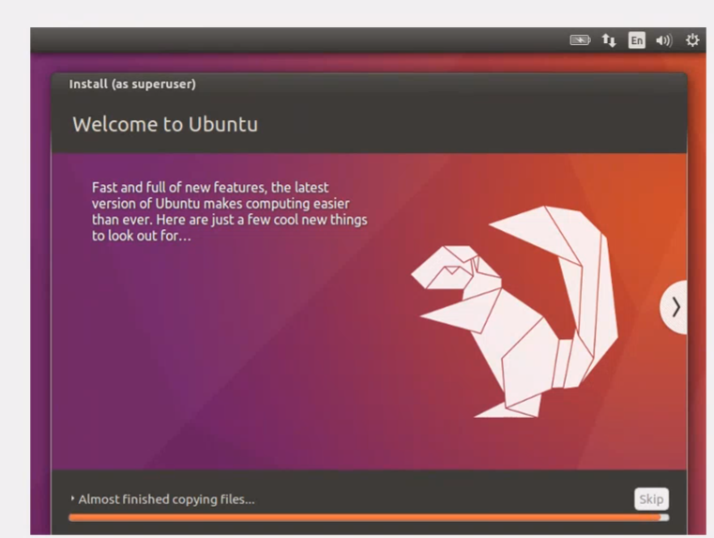

Fig19: And then wait for a while.

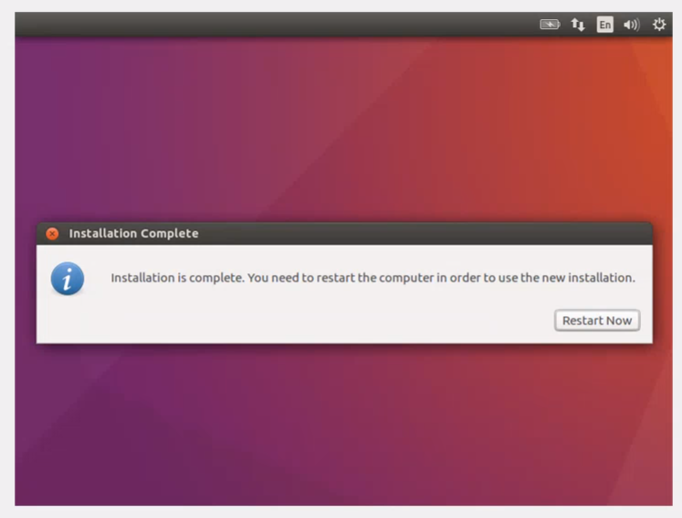

Fig 20: The installation is now complete and restart the computer.

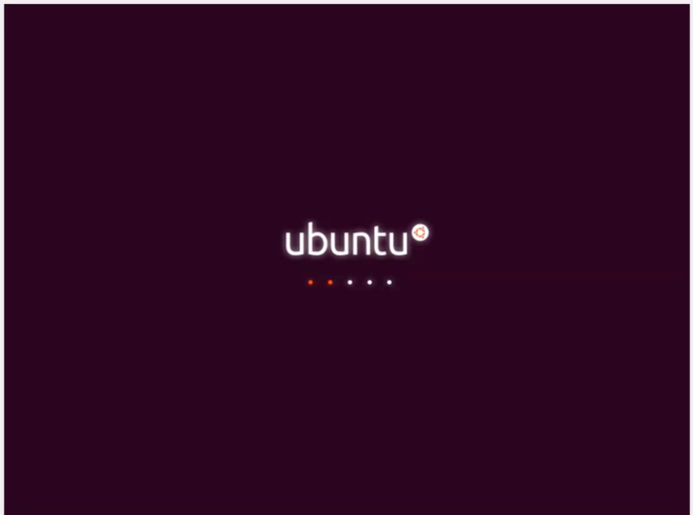

Fig20: Wait a while.

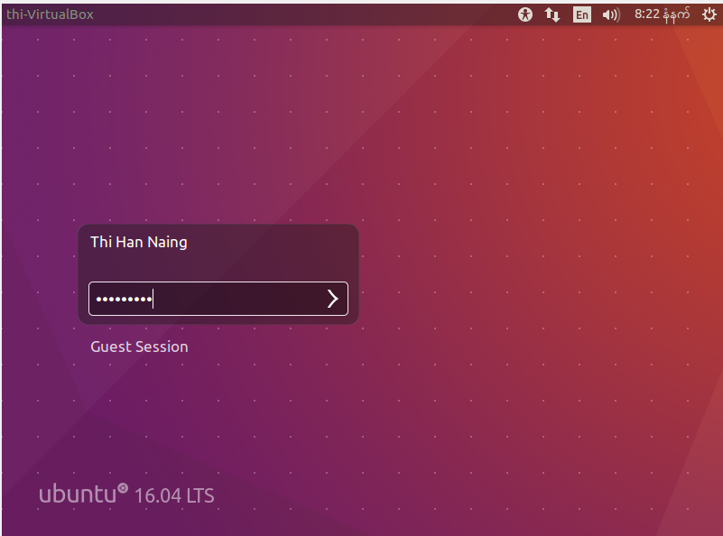

Fig 21:Fill the username and password. The installation is now complete.

(C) Drivers and their sauce locations**.**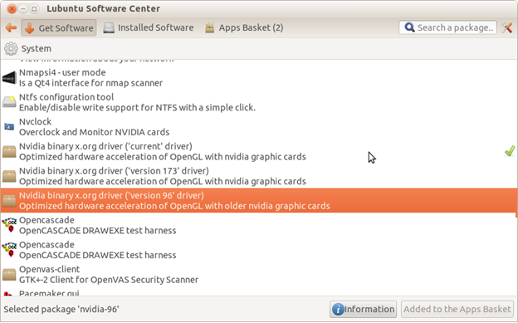

Fig 22: Go to ubuntu software center.

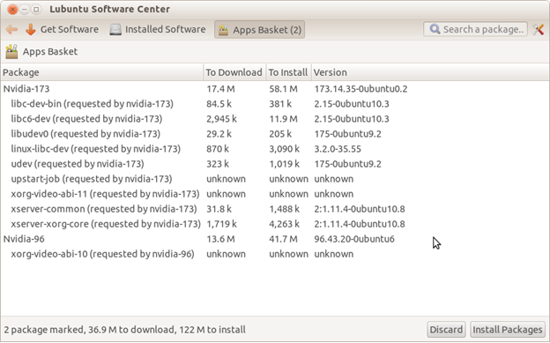

Fig23: Install packages.

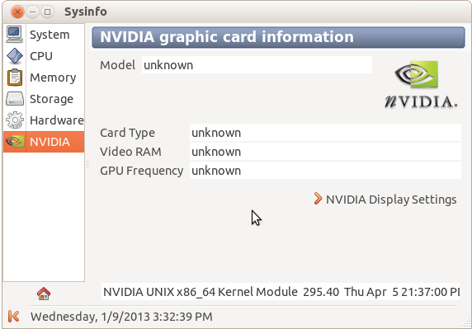

Fig24: We can check the system info and we will see driver is not installed.

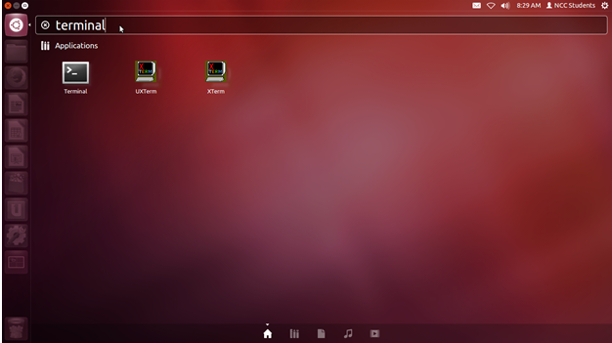

Fig25: Go to the terminal.

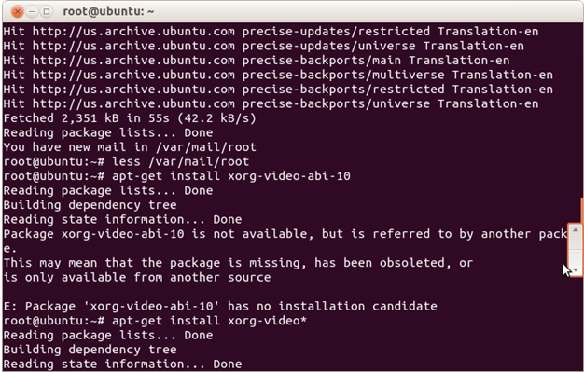

Fig26: Add command prompts.

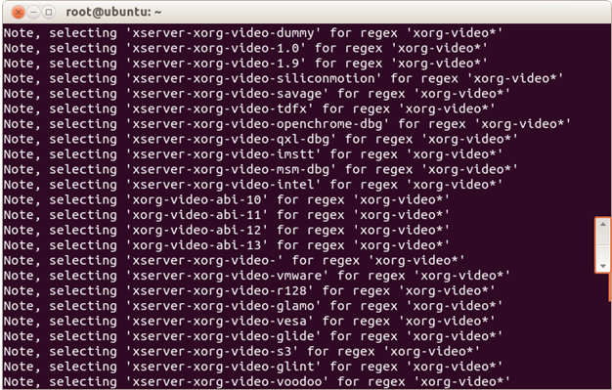

Fig 27: Wait for a while.

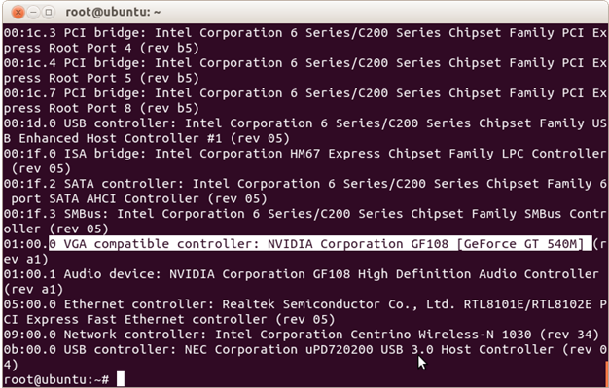

Fig 28: The drivers are installed.

(D) Setting up administrator and standard user.

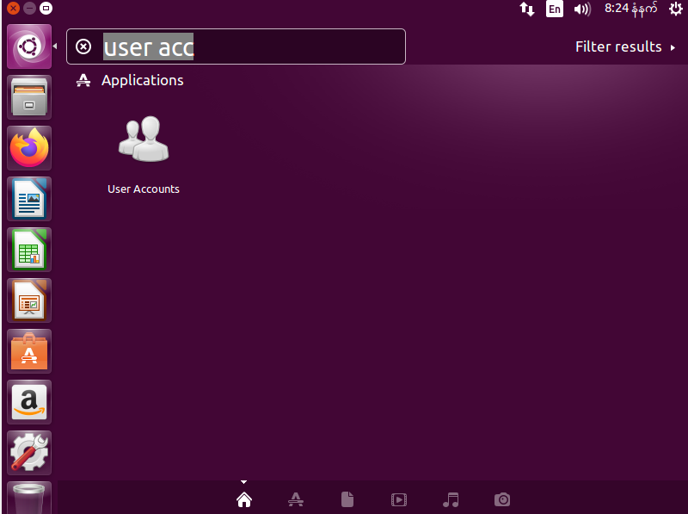

Fig29: To create the standard acc, it is needed to go to the acc setting by searching user account in dash home.

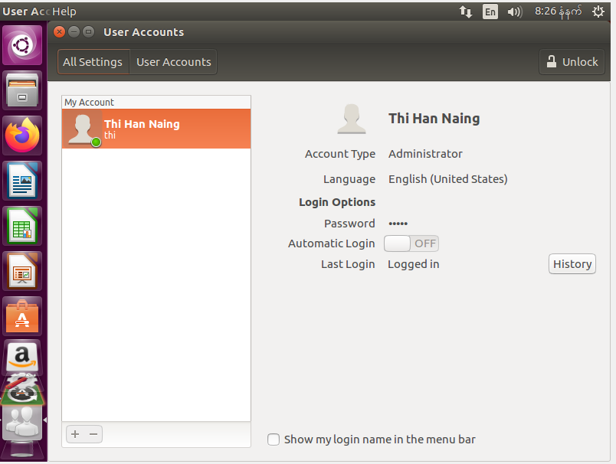

Fig30: This is account setting.

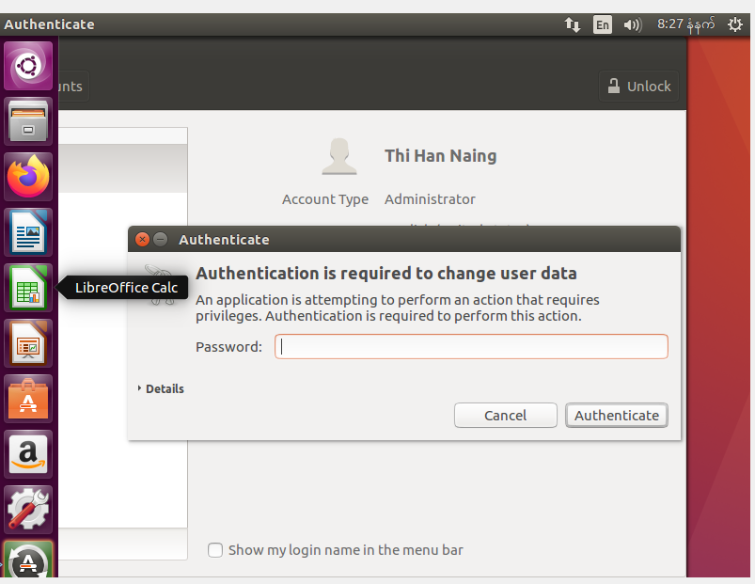

FIg31: To create a standard account, it is need to unlock.

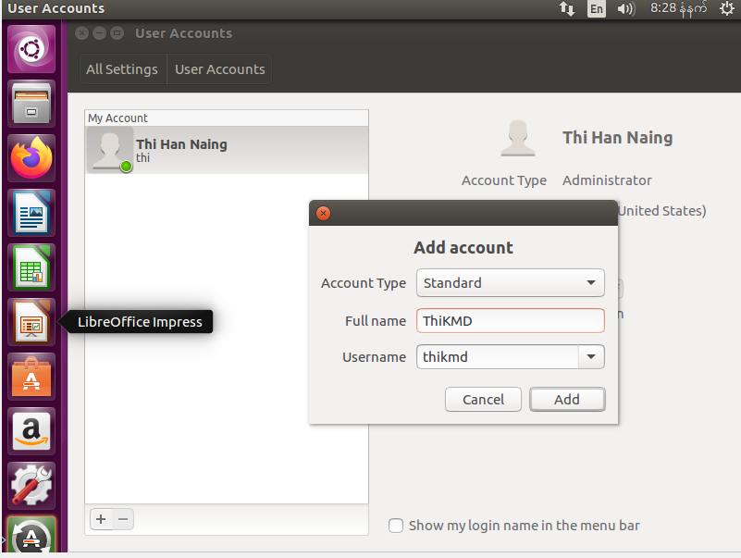

Fig32: Click plus button at the bottom and create a standard account.

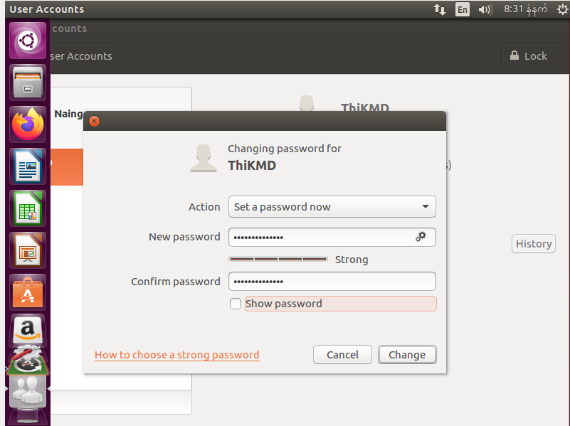

Fig33: Nothing can be done with account is disable so it needs to be changed. To be able to an account, add password.

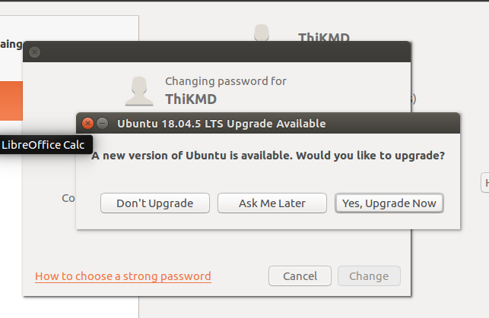Fig34: Choose on the desire.

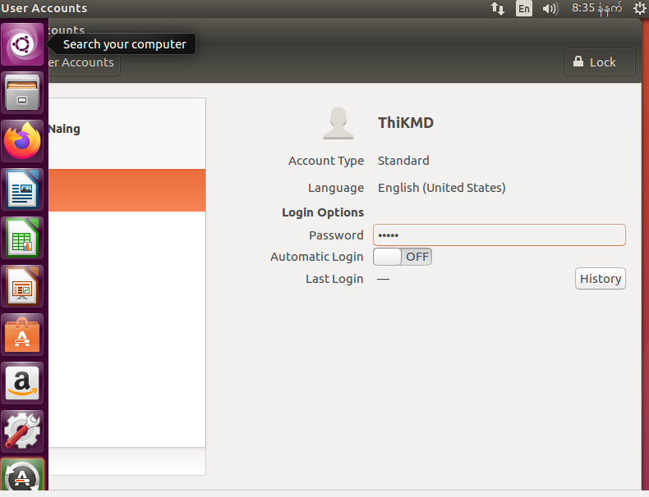Fig35: The account can be used now.

(E) Networking set-up.

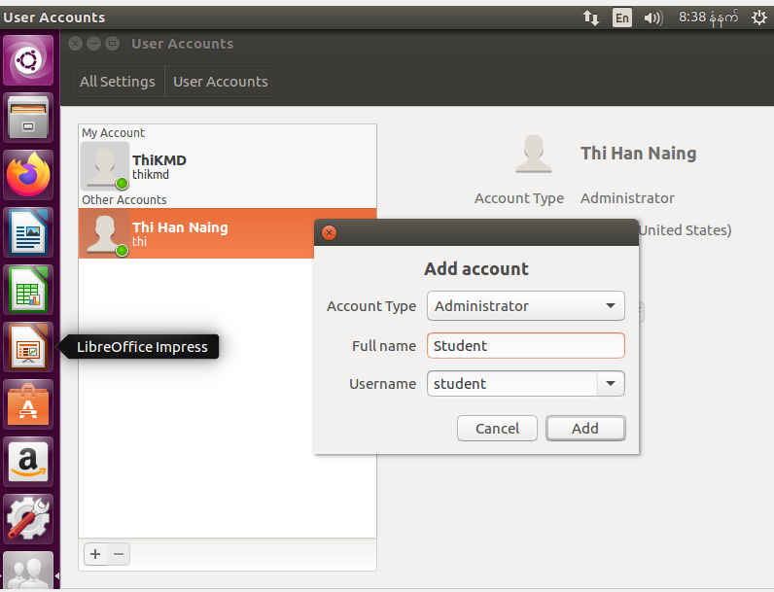Fig36: Create an admin account.

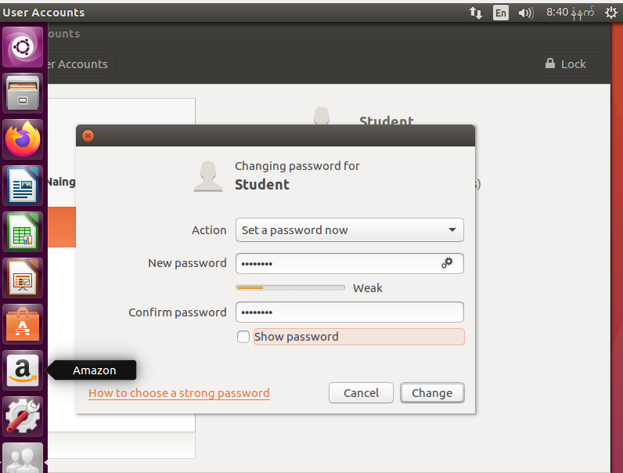Fig37: Change the account disable.

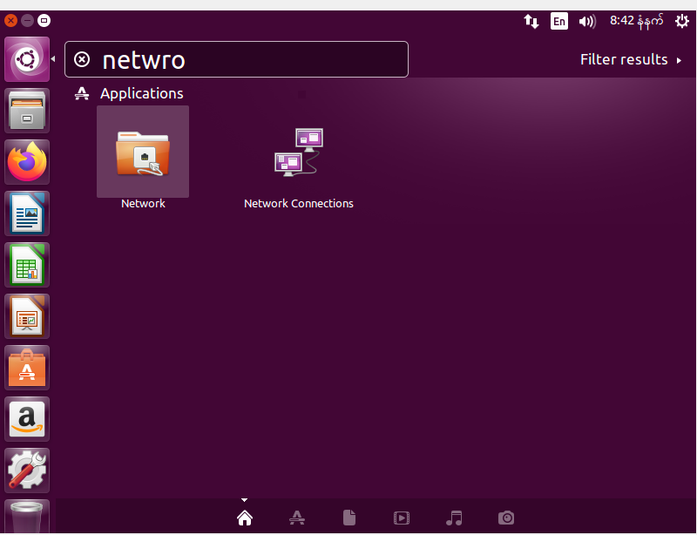

Fig38: Search network connections in dash home.

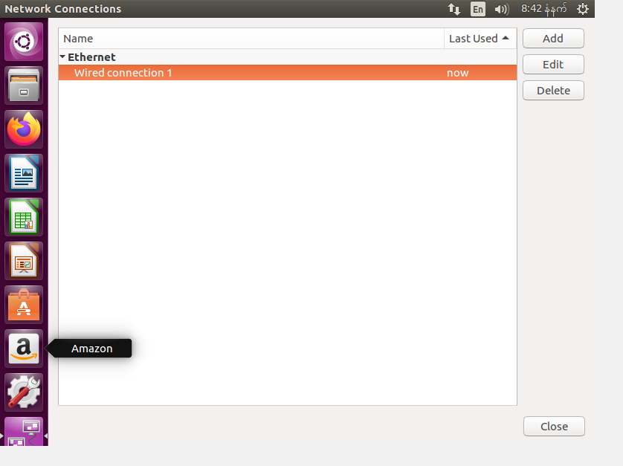

**Fig39 : Click edit by selecting the connection.**

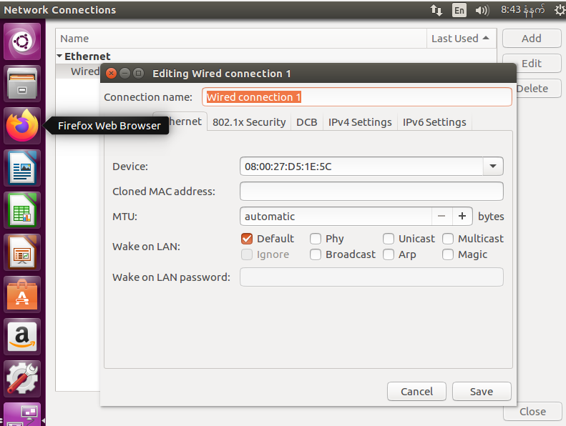

**Fig40 : And choose IP setting.**

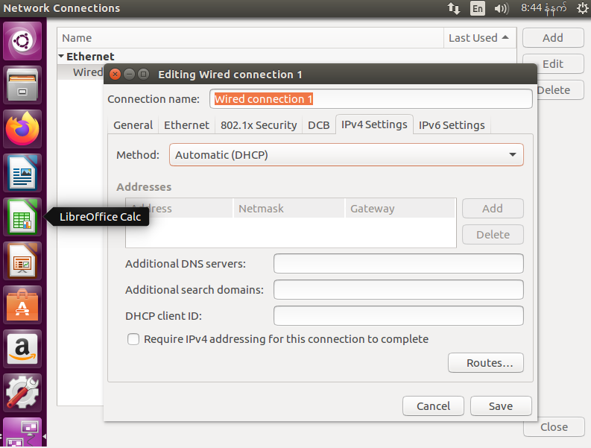

**Fig41: We can choose manual if we know our address. If not, set automatic.**

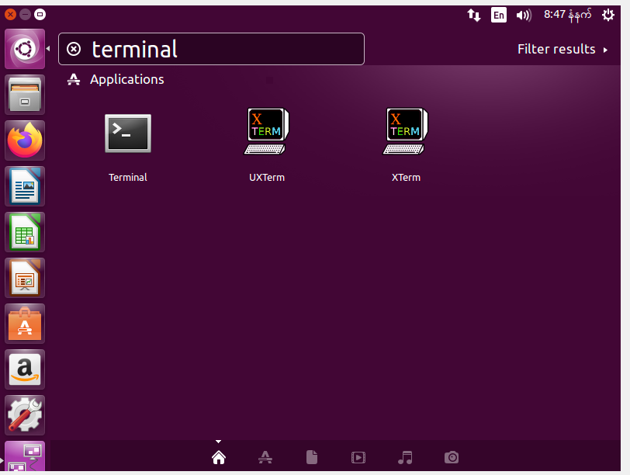

**Fig42: And then go terminal.**

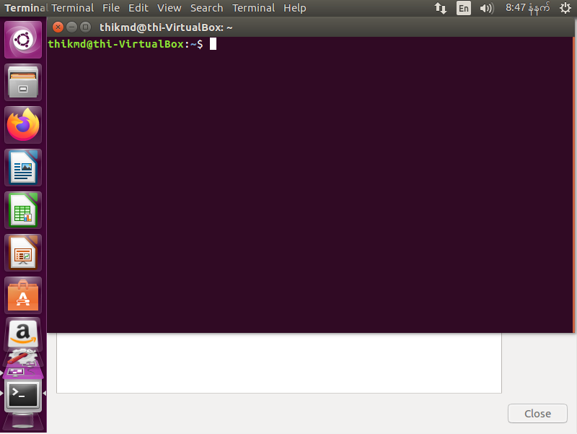

**Fig43: Type the command prompt.**

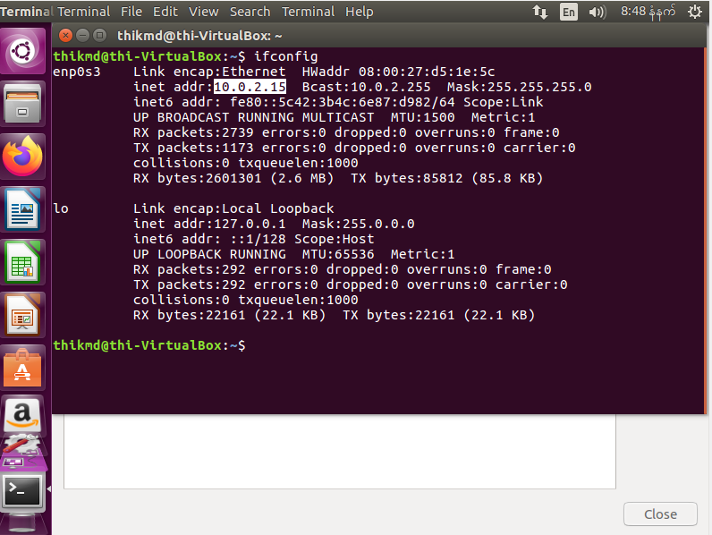

**Fig44: Now the network is connected.**

**(F) Installation process of one application in Linux**

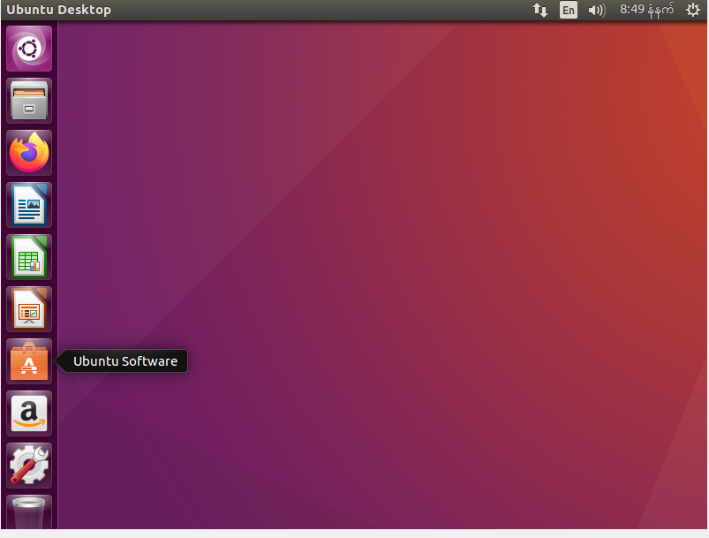

**Fig45: Go to Ubuntu Software.**

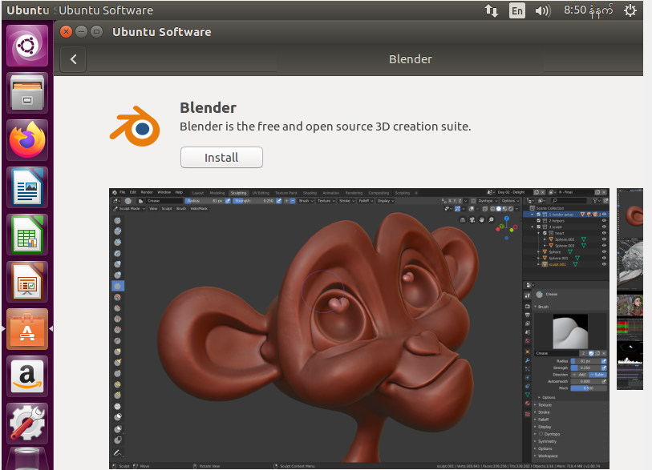

**Fig46: Search an application which you want to install.**

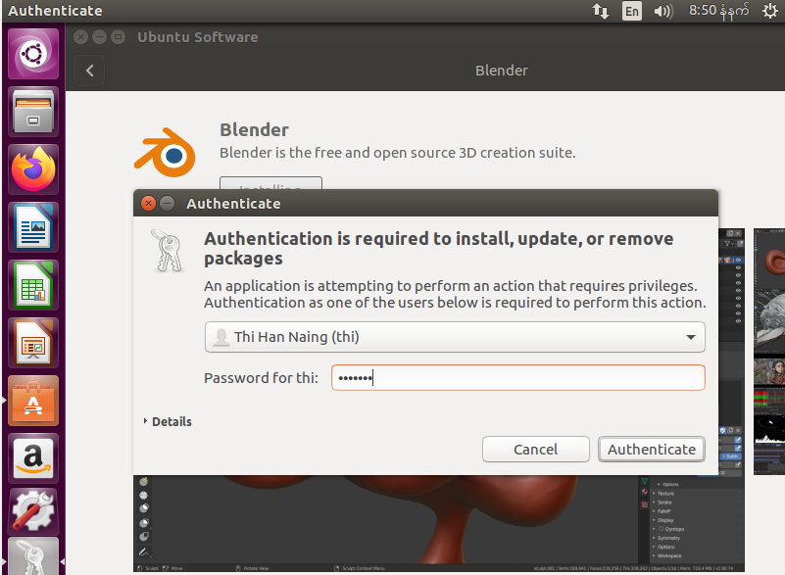

**Fig47: Add the password and install.**

**2.Testing**

**a.Test plan**

**i. Test plan will include testing the monitor, optical device and USB.**

**Ii. Testing need to be pass in all devices.**

**iii. Results during testing.**

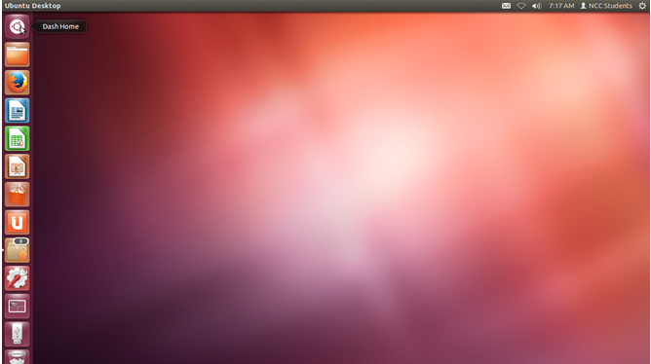

**Go to dash home.**

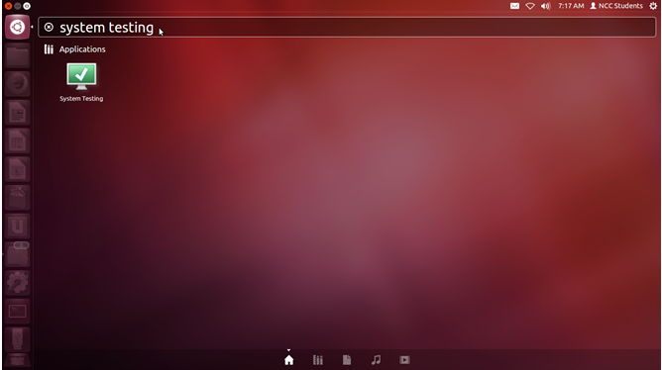

**Search for system testing.**

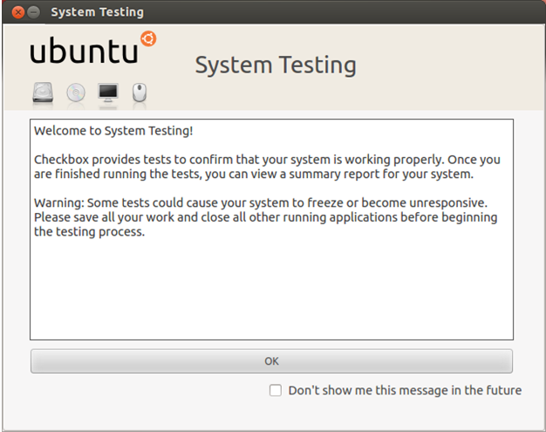

**Click “OK”.**

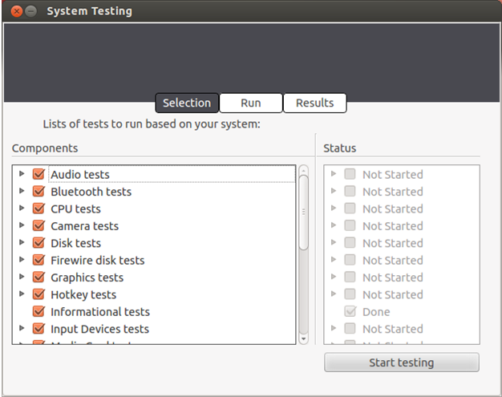

Select all.

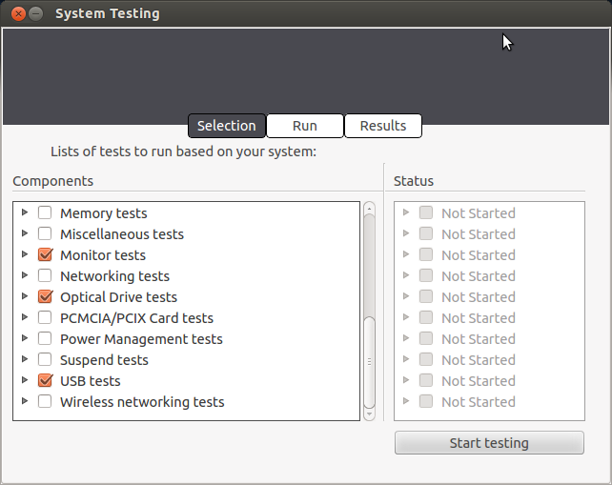

Select monitor, optical drive and USB tests.

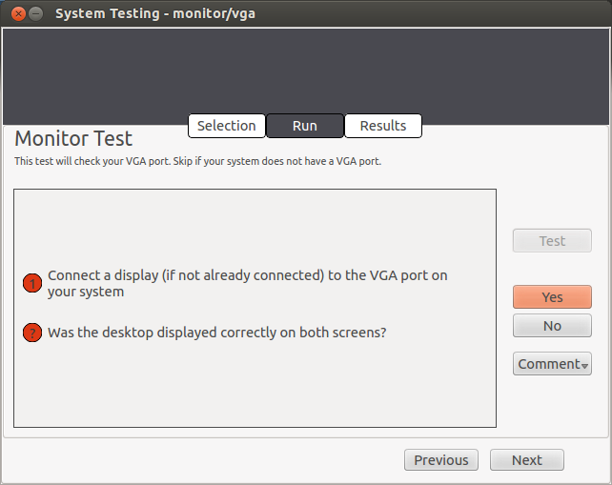

Go to run page and choose “Yes”.

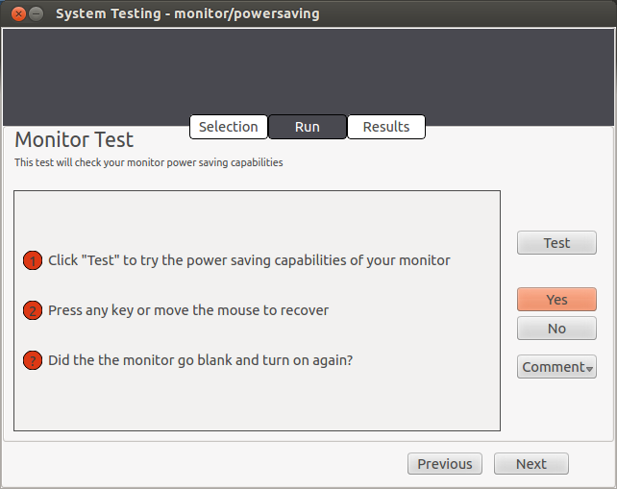

Click “Yes”.

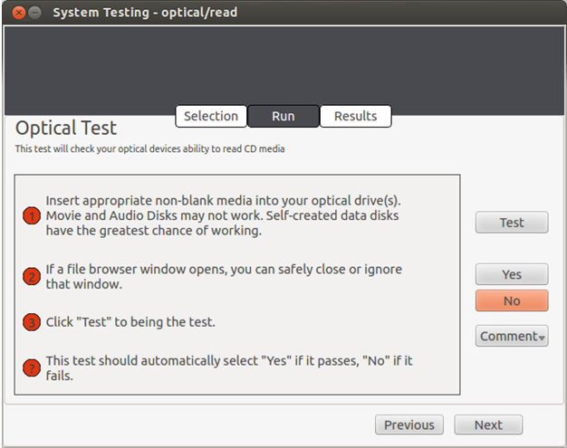

Click next.

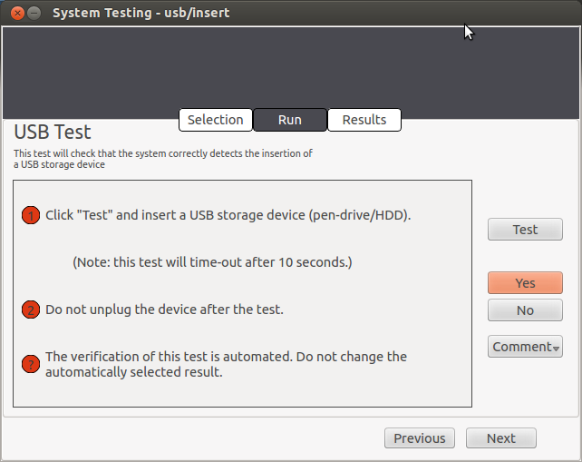

Go to the next.

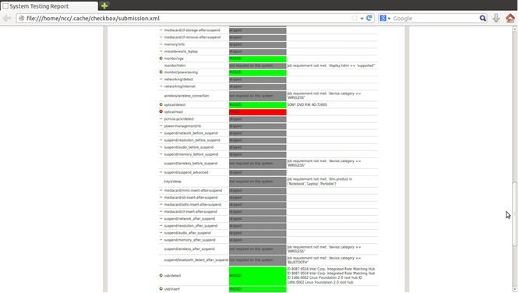

And this is the result for testing.

**Iv.** 

The optical device is connected but it doesn’t read because may be the lens have dust and too long so that it cannot run well.

**TASK 3**

**FAULTY PC**

There are many types of errors for each system units.

CPU fan error

When the screen shows black screen, check the left bottom corner. If it shows about CPU fan error, CPU got something wrong in the system unit.

To solve this problem, press F1 and go to the advance mode by F7. And then go to monitor and change the CPU fan setting to ignore. And then save the setting or click F10.

The CPU fan error can be caused because of temperature and dust. To solve this problem, we need to shut down the PC and open the casing box. And then disconnect the CPU fan from CPU and clean the dust. During this process, the electro discharge tools like Anti-static wrist strap are need to prevent from electricity.

After cleaning the CPU, set it into the system unit box and run the computer back. After doing all this step the CPU fan will get better and the computer will run back.

Hard disk error

Hard disk error usually shows up with the message box.

Most of the hard disk errors are cause because of humans. Sometimes errors can occur due to the power output, viruses and system maintenance.

Disk error can be scan in the file explorer by right the disk and go to the tools and scan the disk driver. If the errors occur, call “Run” and type “gpedit.msc” command. Then go to the system in “Administrative Templates” and chose “Troubleshooting and Diagnostics”. And then click the “Disk Diagnostics” and chose the second setting. And change the setting to disable and save the setting. And then restart the computer.

After restarting, the computer will get better.

Monitor error

Monitor error can be shown up when the display refresh rate got slowed very much or sometime in black screen when open computer.

There are many types of monitor errors depend to device like LCD displayed monitors and OLED displayed monitors. The most common errors are because of the user is using the functions out of the range.

To solve this problem, go to the display setting and change the resolution setting to lower. And then go to the advance setting and enter to displayer adapter properties and change the refresh rate. If the error is cause of resolution, upgrade the graphic card. If the error cause of refresh rate, change the monitor if don’t want to change those settings.

Candidate Checklist

Please use the following checklist to ensure that your work is ready for submission.

Have you read the NCC Education documents 'What is Academic Misconduct? Guidance for Candidates' and 'Avoiding Plagiarism and Collusion: Guidance for Candidates' and ensured that you have acknowledge all the sources that you have used in your work?

Have you completed the 'Statement and Confirmation of Own Work' form and attached it to your assignment? **You must do this**.

Have you ensured that your work has not gone over or under the recommended word count by more than 10%?

Have you ensured that your work does not contain viruses and can be run directly?